

**USER MANUAL SIGN-OFF**

**Authorization Memorandum**

This form is to sign-off completion of the Design Phase for **CAMPUS MANAGEMENT SOFTWARE AT WORLD SKILL CENTER (WSC).**

World Skill Centre (WSC) acknowledges receipt of the deliverables as part of the User Manual Phase through the submission of this document.

|  |  |
| --- | --- |
| **MODULE NAME** | **Accounting** |
| **MODULE OWNER** | **Mr. Bibhu Behura , Mr. Subodha Patra** |

**WSC AUTHORITY NAME AND SIGNATURE**

**SOUL AUTHORITY NAME AND SIGNATURE**

 



**Sustainable Outreach And Universal**

**Leadership (SOUL) Limited**

**User Manual**

Of

**Accounting**

For Implementation of

**Campus Management Software**

at

**World Skill Center (WSC)**

**Confidentiality**

This document is a strictly confidential communication to and solely for the use of the recipient and may not be reproduced or circulated without SOUL Ltd’s prior written consent. If you are not the intended recipient, you may not disclose or use the information in this documentation in any way

**Document Control History**

|  |  |  |  |  |  |
| --- | --- | --- | --- | --- | --- |
| **Date** | **Version No.** | **Created By** | **Affected Sections** | **Reviewed By** | **Updated By** |
| 31-10-2023 | 1.0 | Subhodeep Dey & Diwakar |  |  |  |
| 14-11-2023 | 1.0 |  |  | Sharmistha Panda |  |
|  |  |  |  |  |  |

Table Of Contents

1 Introduction 6

1.1 Background 6

1.2 Scope and Purpose of the document 6

2 General Procedures 7

2.1 General Procedures for a Save Screen 7

2.1.1 Create of New document 7

2.1.2 View a Saved Document 8

2.1.3 Delete a Saved Document 9

2.1.4 Rename a Saved Document 10

2.1.5 Print a Saved Document type 11

2.1.6 View the saved document in different format. 12

2.1.7 View the saved documents by applying filters. 12

2.2 General Procedure for a Submittable Screen 14

2.2.1 Create of New document 14

2.2.2 Cancel a Submitted Document 15

2.2.3 Amend a Submittable Document 16

2.2.4 Delete a Submittable Document 17

2.2.5 Action Menu on a document. 18

3 Accounting Master :- 20

3.1 Company :- 20

3.2 Chart of Accounts :- 23

3.3 Fiscal Year :- 25

3.4 Accounting Period :- 27

3.5 Finance Book :- 28

3.6 Accounting Dimension :- 30

4 General Ledger 31

4.1 Journal Entry 31

4.2 General Ledger 33

4.3 Supplier Ledger Summary 34

5 Accounts Receivable 35

5.1 Payment Entry 35

5.2 Accounts Receivable 37

5.3 Accounts Receivable Summary 38

6 Reports 39

6.1 Trial Balance For Party 39

6.2 Tax Detail 40

7 Financial Statements 41

7.1 Trial Balance 41

7.2 Balance Sheet 42

7.3 Profit and Loss Statement 43

7.4 Cash Flow 44

7.5 Consolidated Financial Statement 45

8 Currency 46

8.1 Currency 46

9 Party 48

9.1 Party Type 48

10 Bank Statement 50

10.1 Bank 50

10.2 Bank Account 52

10.3 Bank Clearance 53

10.4 Bank Reconciliation Tool 54

10.5 Bank Reconciliation Statement 55

11 Accounts Payable 56

11.1 Accounts Payable :- 56

11.2 Accounts Payable Summary :- 57

11.3 Purchase Register :- 57

11.4 Item-wise Purchase Register :- 58

12 Mode of Payment :- 59

13 Cost Center :- 60

14 Fixed Deposit :- 61

15 Security: User access and authorization 63

# Introduction

The World Skill Center (WSC) is a premier advanced skill training institute established by the Government of Odisha, Skill Development and Technical Education Department, through the Odisha Skill Development Authority (OSDA). The WSC will impart advanced skill training in eight trades from engineering and service sectors. WSC caters primarily to induct the best talent from ITIs and Polytechnics and training them to become globally employable in emerging areas such as "Industry 4.0". WSC is housed in a state-of-the-art, 18-storey, air-conditioned building with nearly half a million square feet of space in the heart of capital city of Bhubaneswar.

With the implementation of campus management software for WSC the goal is to streamline the operations and functions of the campus by integrating various processes, such as admissions, course registration, academic progress tracking, and financial management, HRMS, Procurement and Inventory management, etc into a unified system. The implementation also aims at providing a user-friendly interface for all stakeholders, making it easier for them to access the necessary information and complete their tasks with ease. The modules to be covered during the implementation of the software include:

|  |  |
| --- | --- |
| Students Management Modules | Infrastructure Management |
| Academic System | Finance and Accounting System |
| Procurement & Inventory Management | Training and Placement |
| Human Resources Management System | Application Integration |

# 

## Background

The Web Based Campus Management Application at World Skill Centre (WSC) application is required by WSC for the smooth operation of all departments / support functions with on-line delivery of services to all stakeholders.

The project aims to create a mechanism to provide the basis for evolution of an IT enabled state of the art workflow automation system in a planned manner.

## Scope and Purpose of the document

The design documents track the necessary information required to effectively define architecture and system design in order to give the development team guidance on the architecture of the system to be developed. Its intended audience is the project manager, project team, and development team. Some portions of this document, such as the user interface (UI), may be shared with the client/user, and other stakeholders whose input/approval into the UI is needed.

This document covers all the design aspects of **Finance and Accounting** module. This module helps in organizing the entire finance setup such as Company, Fiscal Year, Payment Entries etc.

The scope of **Finance and Accounting** module are:

* Receipt and Payment Entries
* Direct Transfer of Caution Money to Student’s Accounts
* Demand Register
* Caution Money Register
* Bank Reconciliation Statement
* Generation of Cash Book (PL)
* Grants-in-aid Register
* Paid Voucher Register
* Advances Register
* Auditing and Tracking Pendency of Audit paras etc.

# General Procedures

## General Procedures for a Save Screen

### Create of New document

* Login in to the system
* Go the required menu

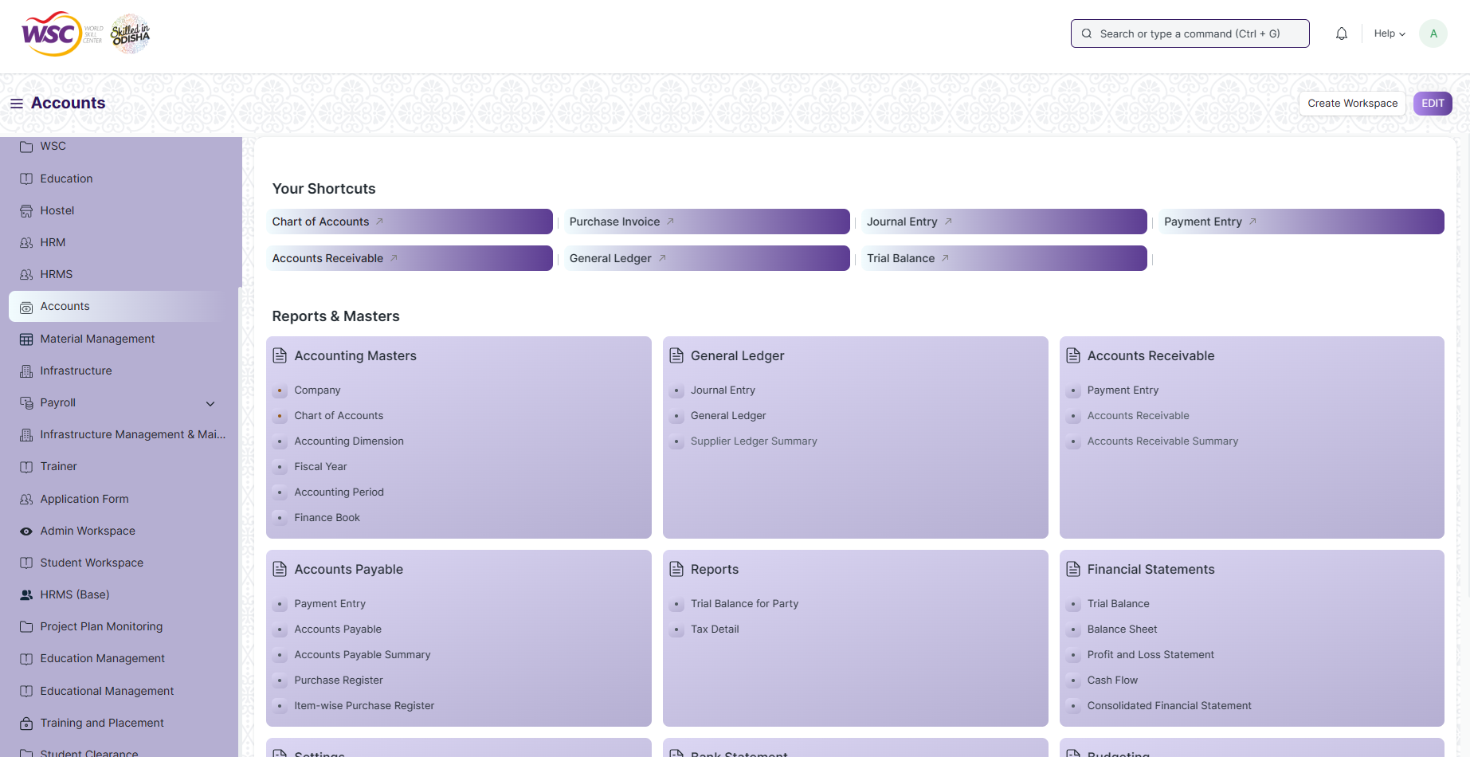

* Go to the required screen.
* Click on the ***“+Add Screen Name”*** button in the right corner of the screen.

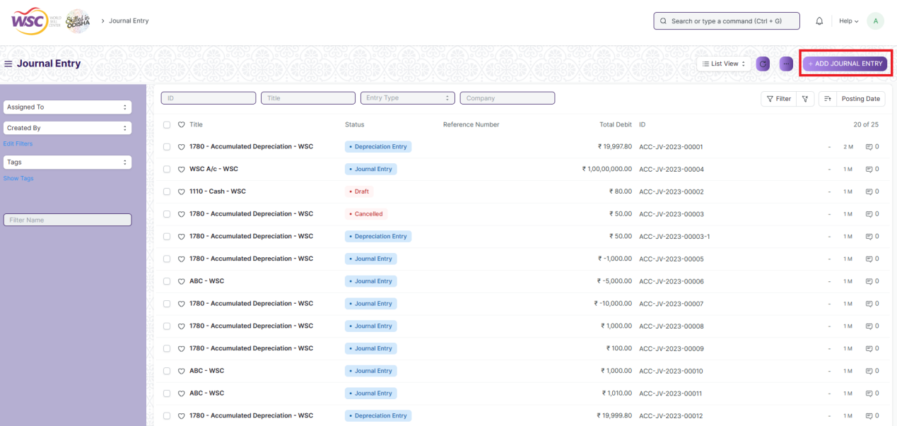

(Example : For addition in the new Journal Entry , click +Add Journal Entry button).

* Enter the required data.
* Click on “***Save”*.**
* After saving , the record will be visible in the List View of the screen

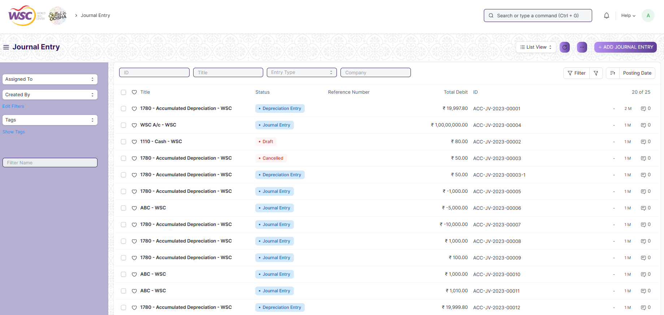

(Example : List view of saved Journal Entries)

**Note :** The process of creation can only be carried out by employees who have necessary permission.Kindly refer to the Screen wise permission section in the document.

### View a Saved Document

* Log in to the system.
* Go to the required menu
* Go to the required screen.
* Click on the required document from the list view of the screen.

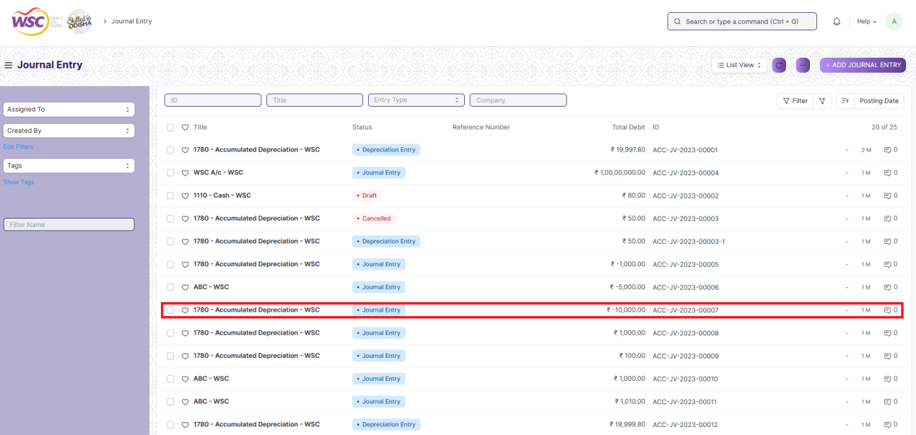

(Example : View of “Journal Entry” Document of Journal Entry Screen)

View the clicked document.

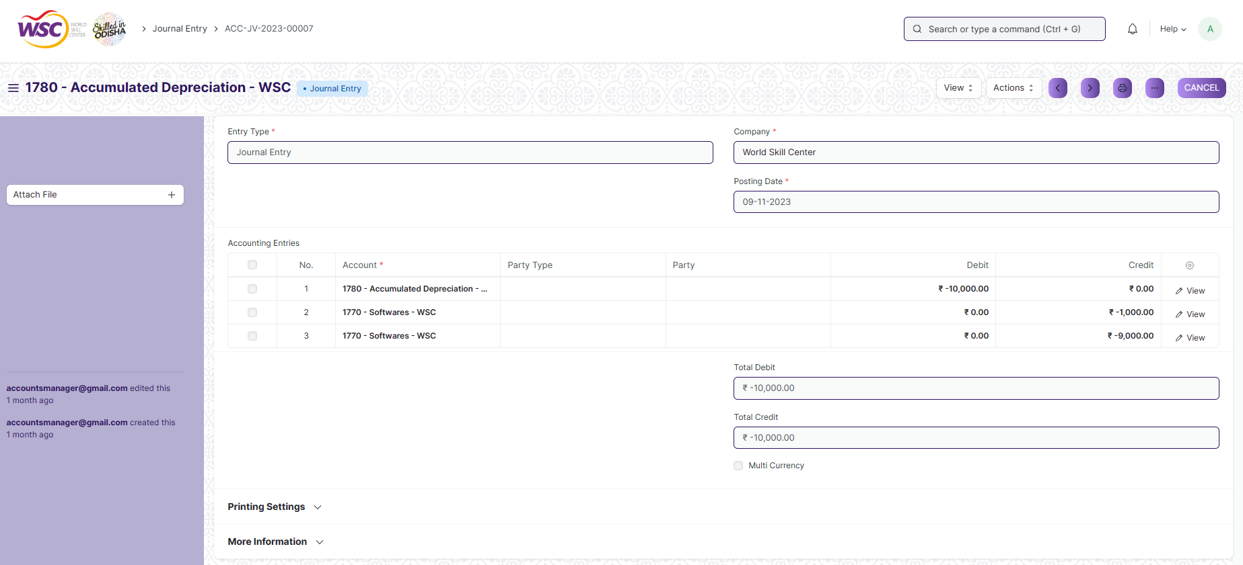

(Example : View of the Journal Entry)

**Note :** The process of view can only be carried out by employees who have necessary permission.Kindly refer to the Screen wise permission section in the document.

### Delete a Saved Document

* Log in to the system
* Go to the required menu
* Go to the required screen.
* Click on the required document from the list view of the screen.
* Click on the 3 dots in the right corner of the screen.
* Click on *“****Delete”*.**

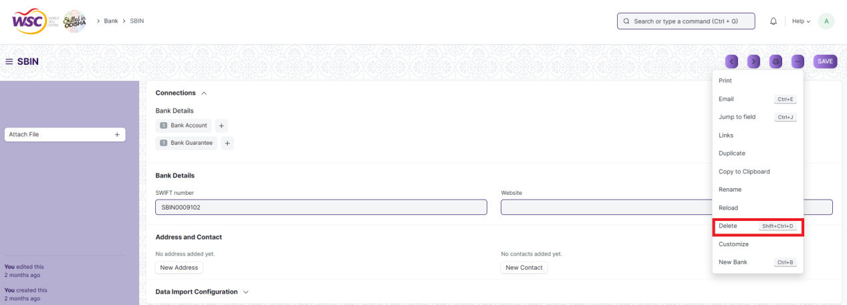

(Example : Deletion of “Bank” document of Employment Type)

Click yes if you want to delete the selected document.

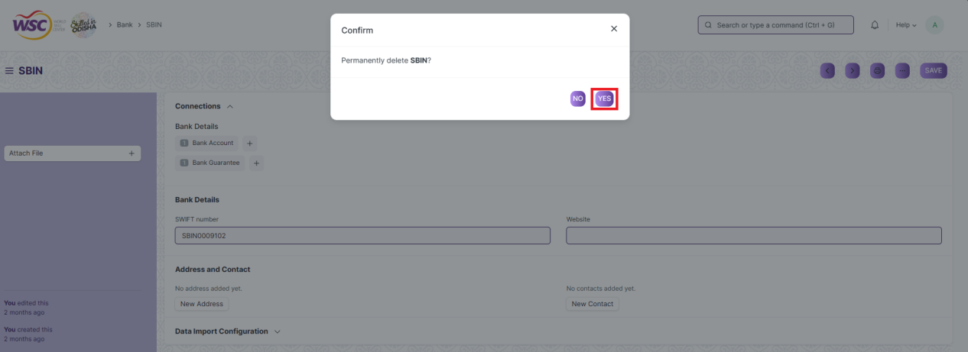

(Example : Clicking Yes to Delete permanently the document)

**Note :** The process of deletion can only be carried out by employees who have necessary permission.Kindly refer to the Screen wise permission section in the document.

### Rename a Saved Document

* Login to the screen.
* Go to the required menu
* Go to the required screen.
* Click on the required document from the list view of the screen.
* Click on the 3 dots in the right corner of the screen.
* Click on *“****RENAME”*** .

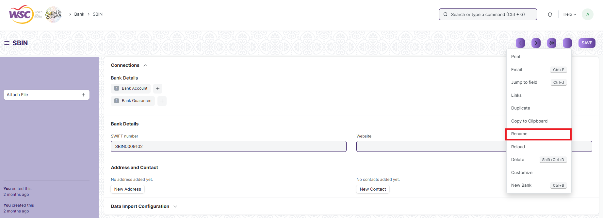

Click on *“****Rename”*** button to rename the document.

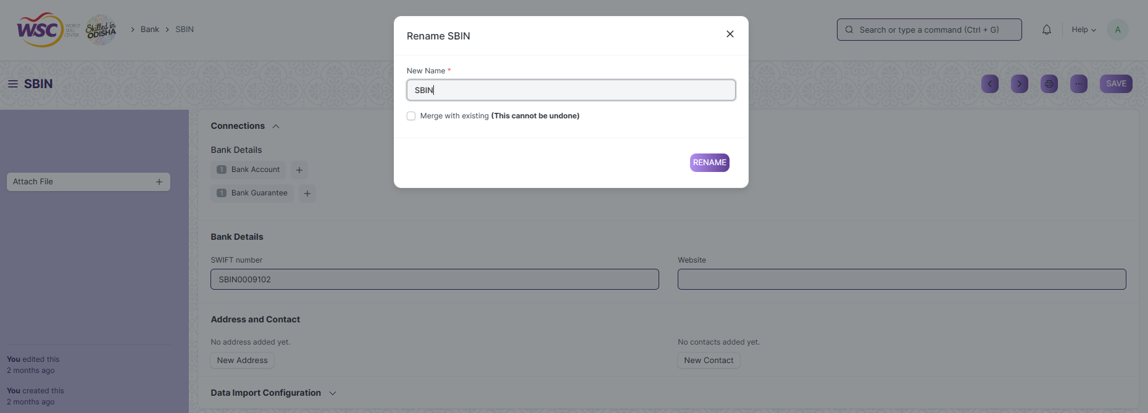

**Note :** The process of deletion can only be carried out by employees who have necessary permission.Kindly refer to the Screen wise permission section in the document.

### Print a Saved Document type

* Login to the system
* Go to the required menu
* Go to the required screen.
* Click on a saved document in the screen.
* Click on the print button present in the right corner of the screen.

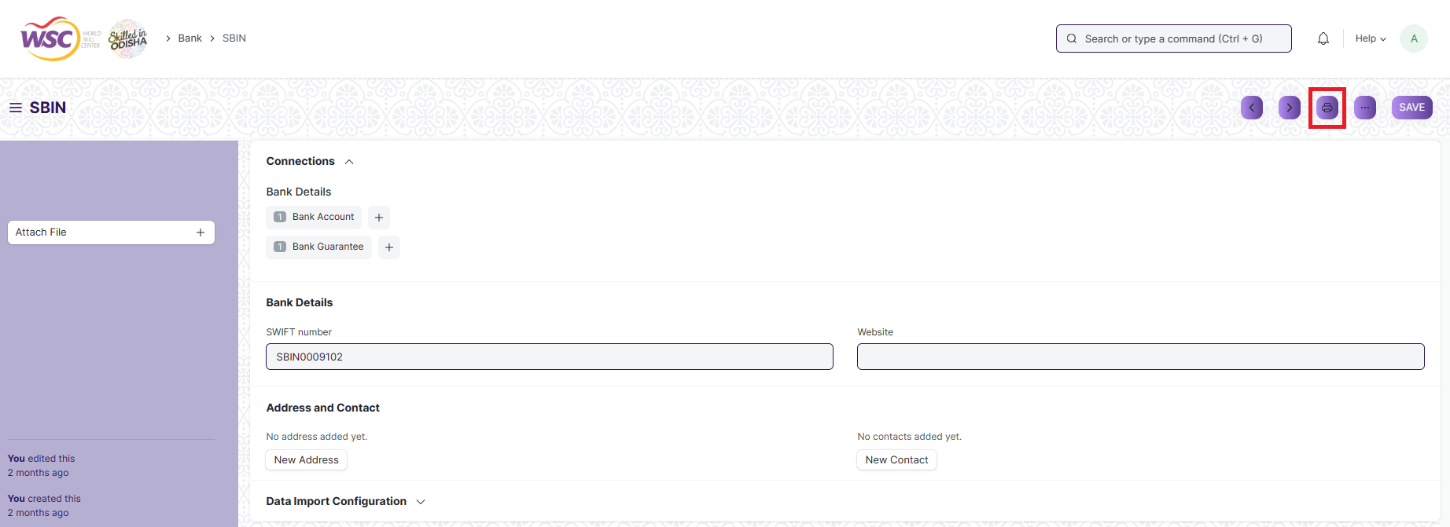

A new screen will open.

Click on the print button to Print the document.

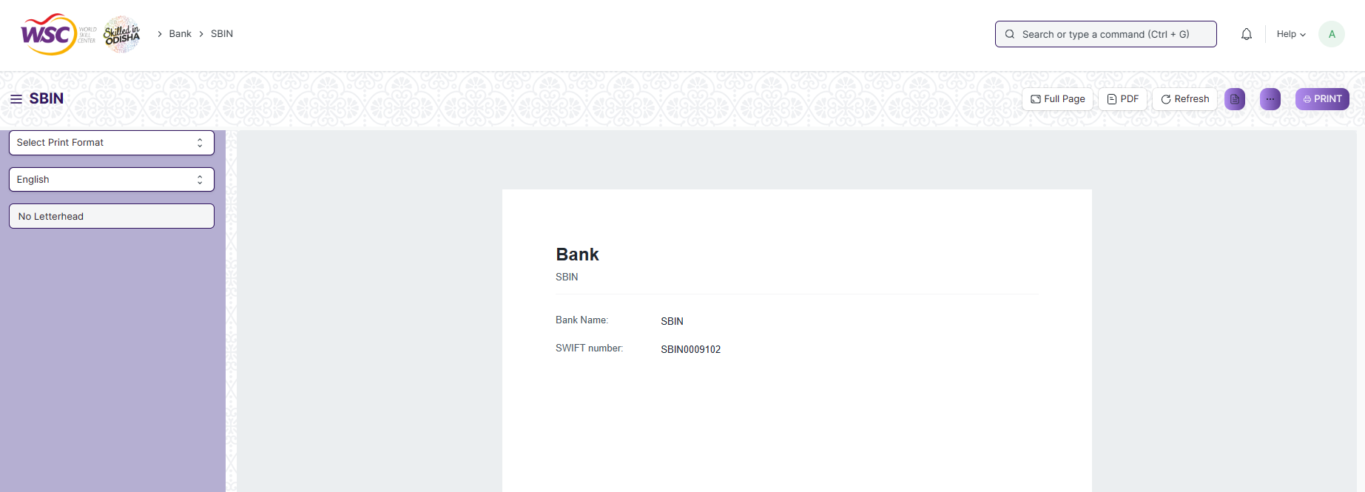

To download the Bank as PDF , click on the PDF button .

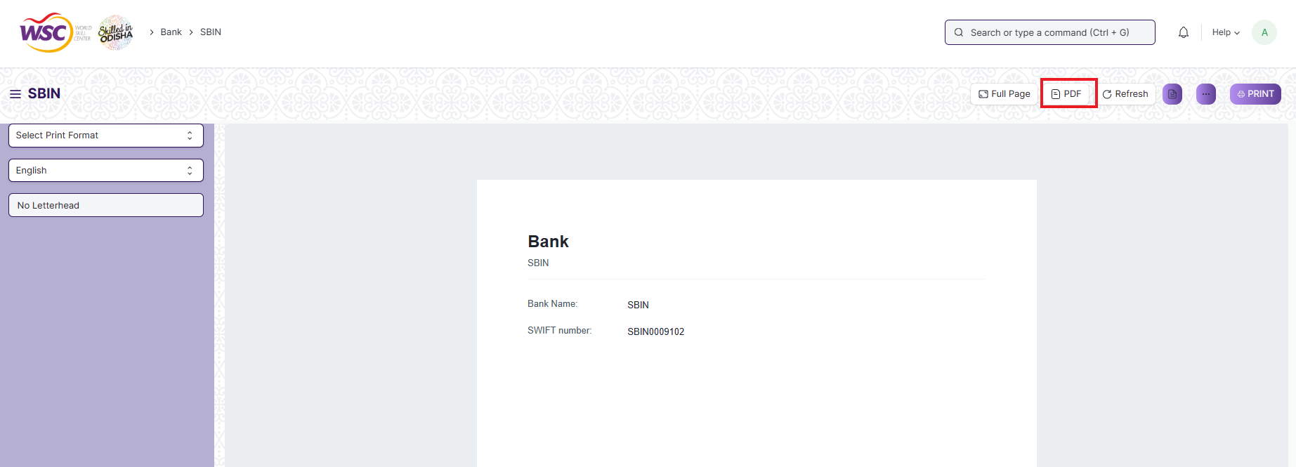

**Note :** The process of printing can only be carried out by employees who have the necessary permission.

### View the saved document in different format.

* Login to the system
* Go to the required menu
* Go to the required screen.
* Click on the List View Button in the screen.

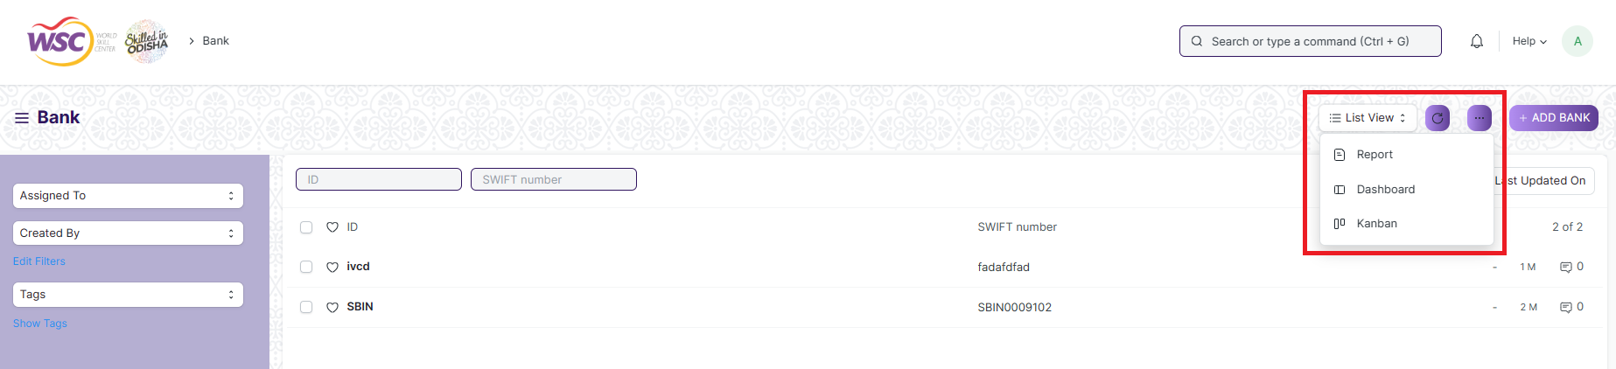

Select the appropriate view type that you want.

**Note :** The List view button can only be showed to the employees who have necessary permission.

### View the saved documents by applying filters.

* Login to the screen.
* Go to the required menu.
* Go to the required screen.
* Click on the ***“Filter”***.

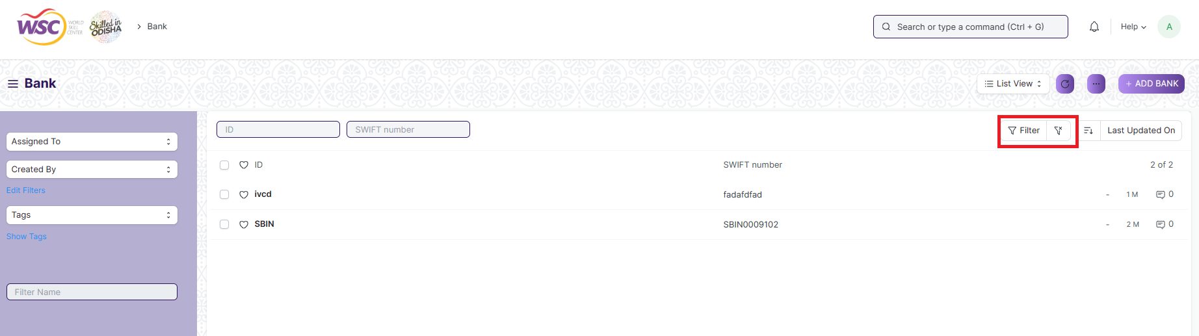

* Select the field of the document based on which you wish to filter the records. All the fields in a form will be selectable in this list.

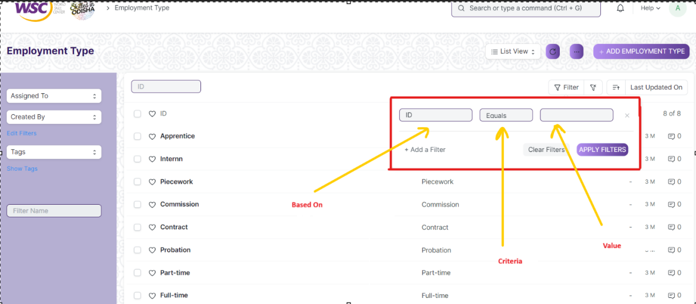

**Based On :** For the field, you will be required to put a value of the field. In the 'based on' field.

**Criteria :** You can define criteria based on which the system will search the document.The different conditions on which the filters are based are: Equals, Not Equal, Like, Not Like, In, Not In, =,>,< etc.

**Value :** Here, you will be required to enter the value for which you are running the document search.

**Some Examples of Viewing the documents in the list view after applying filters.**

Filter on Bank screen where ID Equals to SBIN. After clicking the Apply Filter button, all the filtered document will show in the screen.

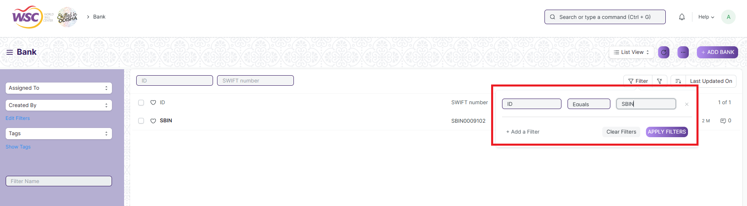

Filter on Bank Screen where, the full name starts with ‘S’.

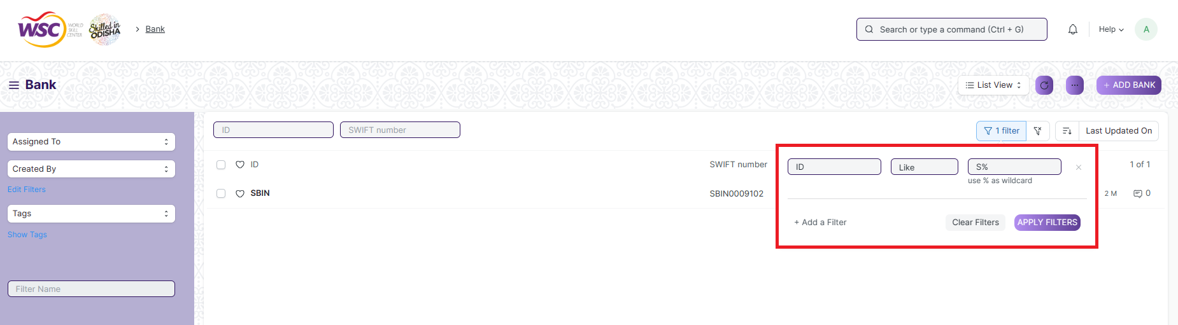

Filter on Bank Screen , where ID is like a particular set of characters.

You can also apply multiple filters at a time. To remove a specific filter, just click on 'x' sign on it. To add another filter Click on the +Add a Filter button.

**Example of Multiple filter .**

Applying filter in the employee screen , where date of joining is greater than some date and gender is equal to Male.

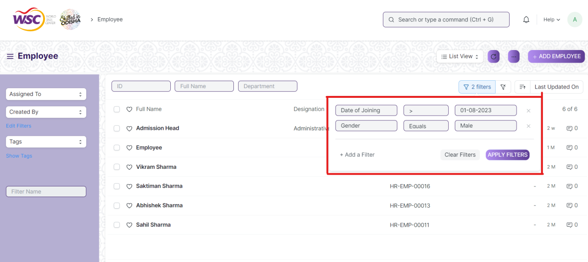

**Default Filters**

There are some filters present out of the box for the views which can be used for filtering the search results.

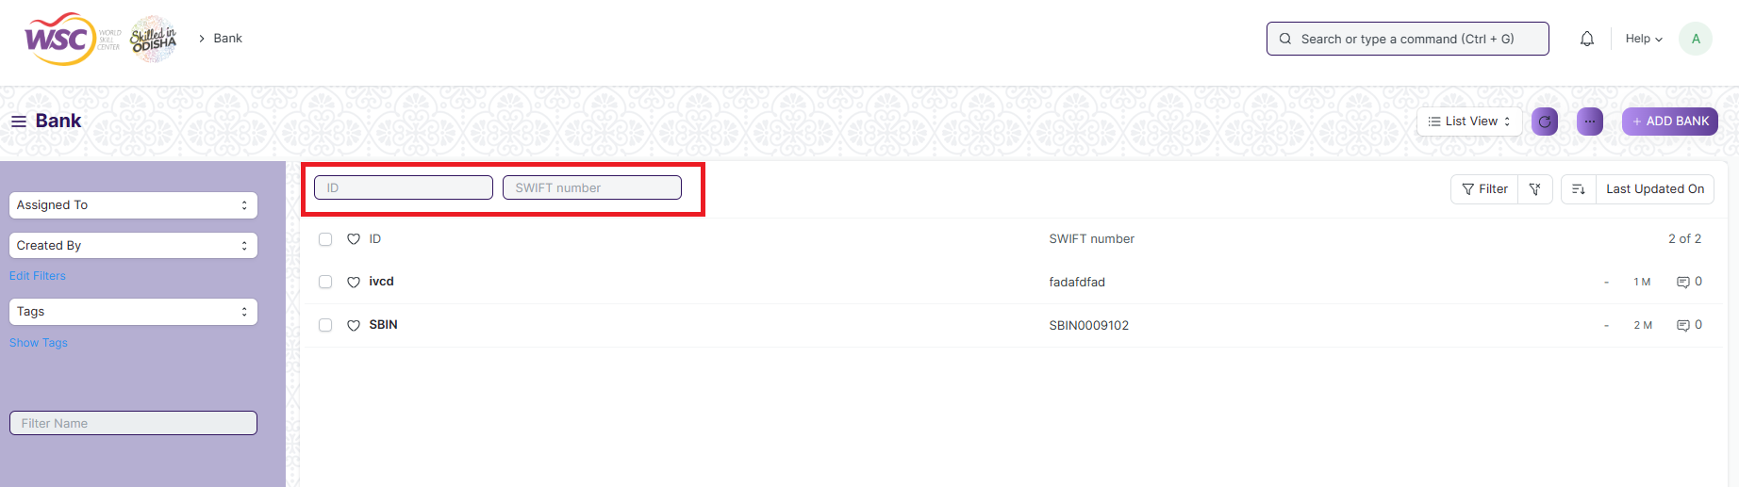

**Note :** The Filter Option can only be showed to the employees who have necessary permission.

## General Procedure for a Submittable Screen

### Create of New document

* Login in to the system
* Go the required menu
* Go to the required screen.
* Click on the ***“+Add Screen Name”*** button in the right corner of the screen.

(Example : For addition in the new Bank , click +Add Bank button).

* Enter the required information in the document.
* Once you are finished entering the information , click the ***“Save”*** button.
* After saving it , a submit button will appear.

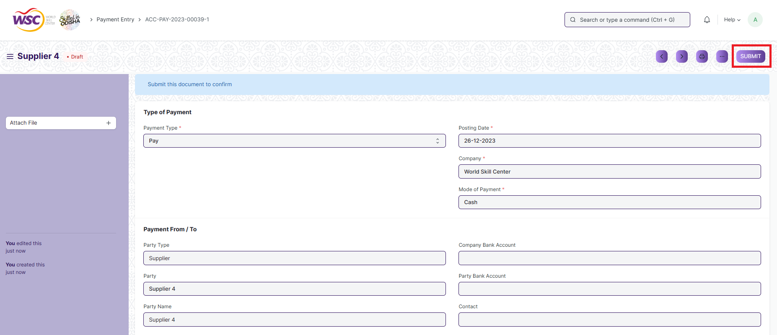

Click on the **“Submit”** button.

A confirmation dialog box will appear . Click the Yes button to submit the document.

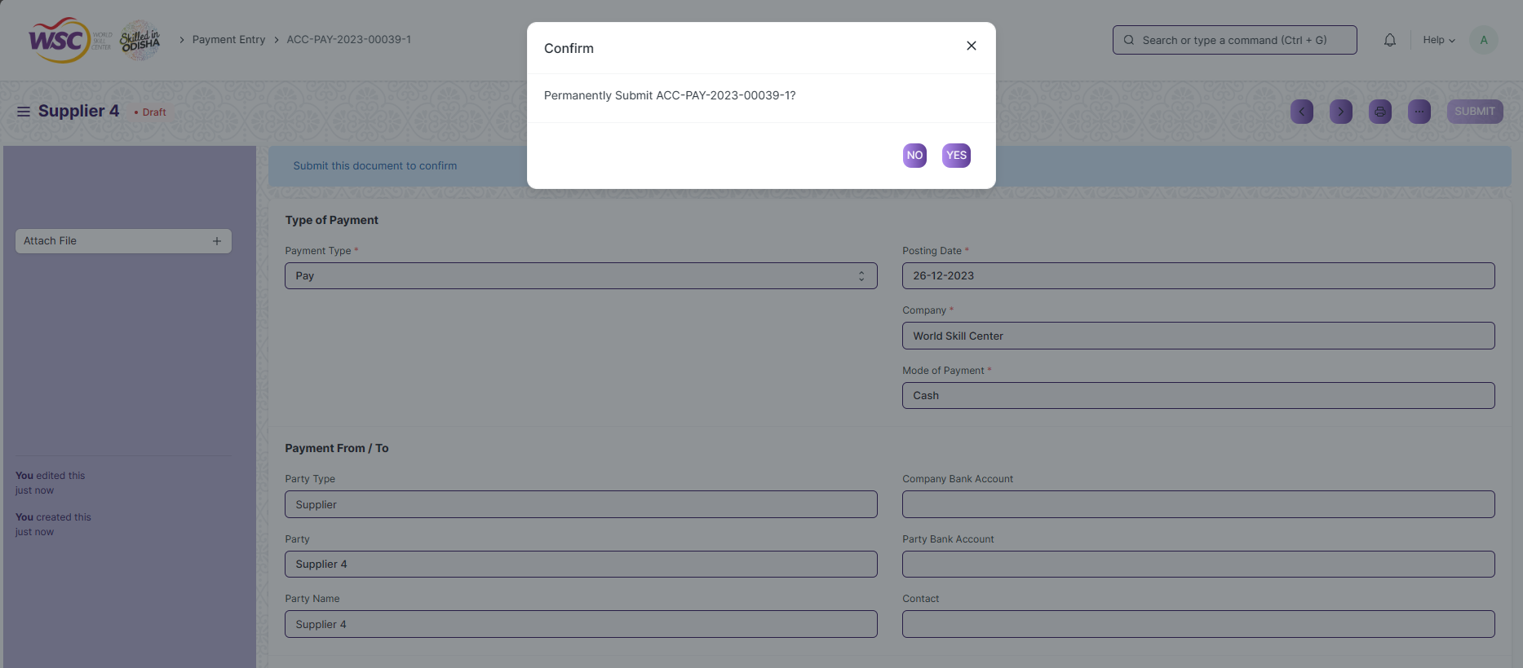

After submitting , the record will be visible in the List View of the screen.

**Note :** The process of creation can only be carried out by employees who have necessary permission.Kindly refer to the Screen wise permission section in the document.

### Cancel a Submitted Document

* Log in to the system.
* Go to the required menu
* Go to the required screen.
* Click on the required document from the list view of the screen.
* Click the ***“Cancel”*** Button .

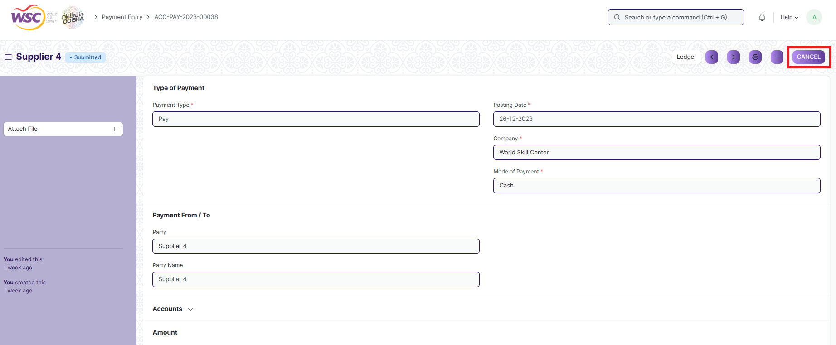

A confirmation dialog box will appear . Click the Yes button to cancel the document.

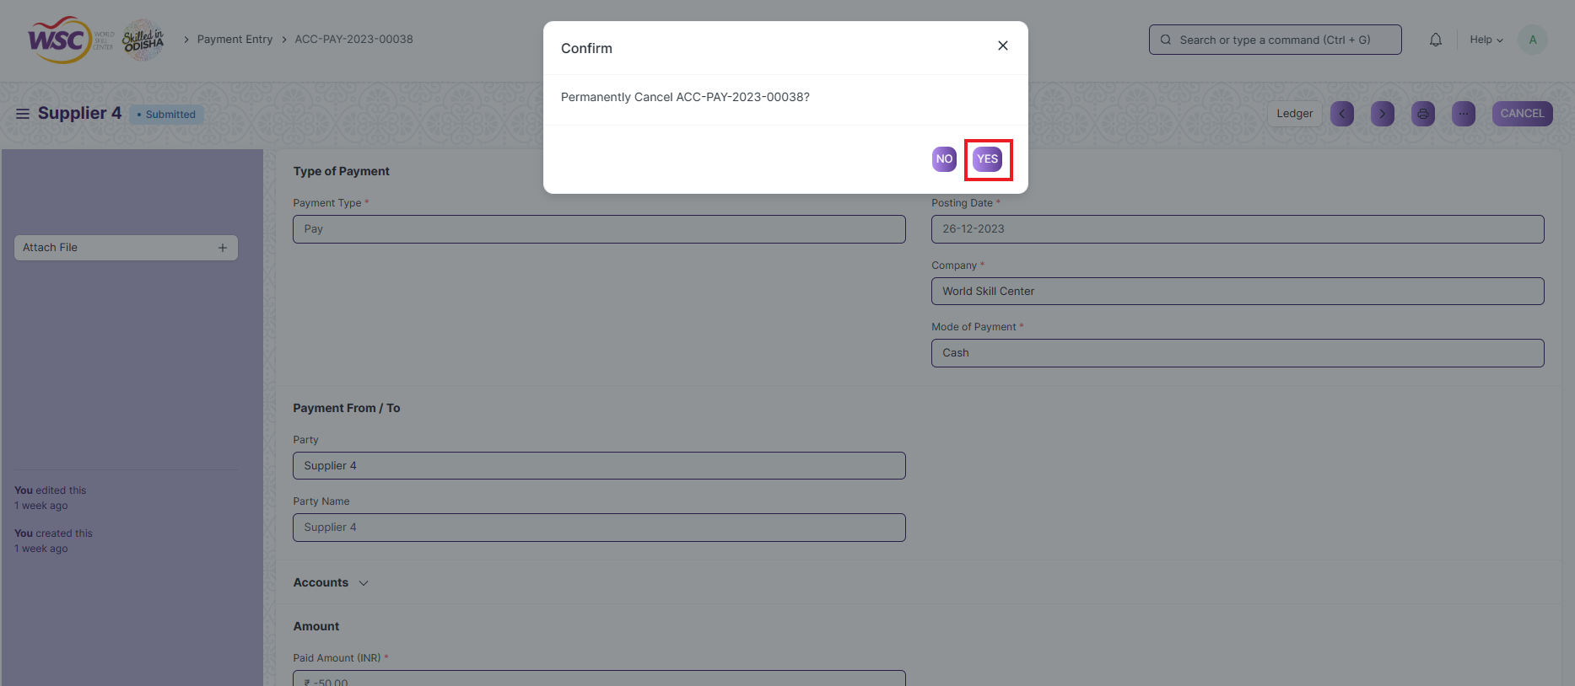

**Note :** The process of cancellation can only be carried out by employees who have necessary permission.Kindly refer to the Screen wise permission section in the document.

### Amend a Submittable Document

* Log in to the system.
* Go to the required menu
* Go to the required screen.
* Click on the required document from the list view of the screen.
* After cancellation of the document , an Amend button will appear on the screen.

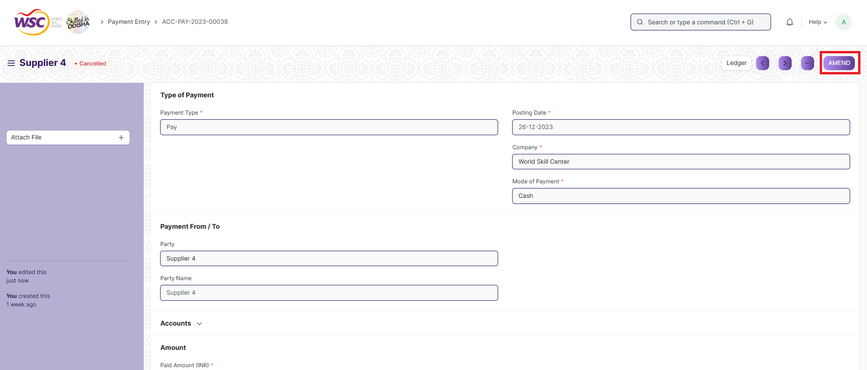

Click the “***Amend”*** button.

A new document will be created with the same information as the original document .

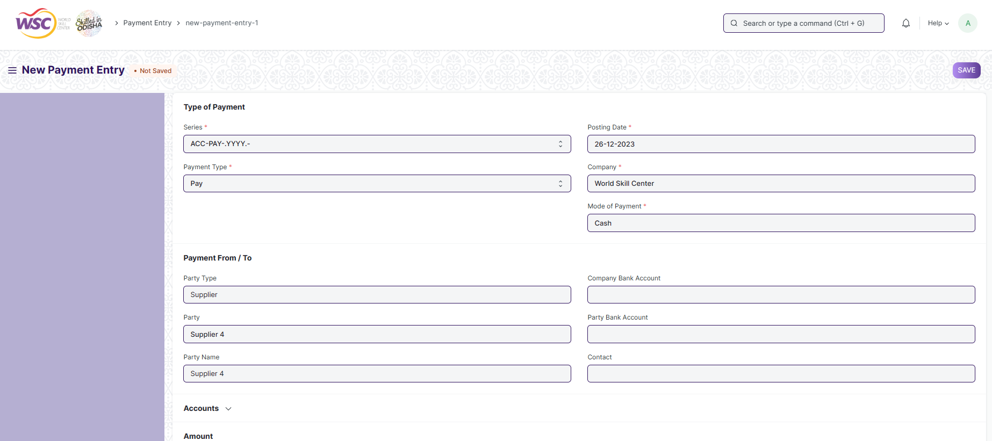

You can now make changes to the document as needed.

**Note :** The process of Amend can only be carried out by employees who have necessary permission.Kindly refer to the Screen wise permission section in the document.

### Delete a Submittable Document

* Log in to the system.
* Go to the required menu
* Go to the required screen.
* Click on the required document from the list view of the screen.
* If the document is in draft sate , you can follow the procedure to delete a save document .
* If the document is submitted , then cancel it first , then delete it.

After cancellation of the document , an Amend button will appear on the screen.

**Note :** If the document you are deleting is linked with any other document , then cancel the dependent document  first , then try to delete it.

Example :

In the Attendance Request Screen, when an attendance request  record is Approved , then a record in the attendance screen will be created.  it is not allowed for deletion of the attendance request record until the associated attendance record is canceled or deleted.

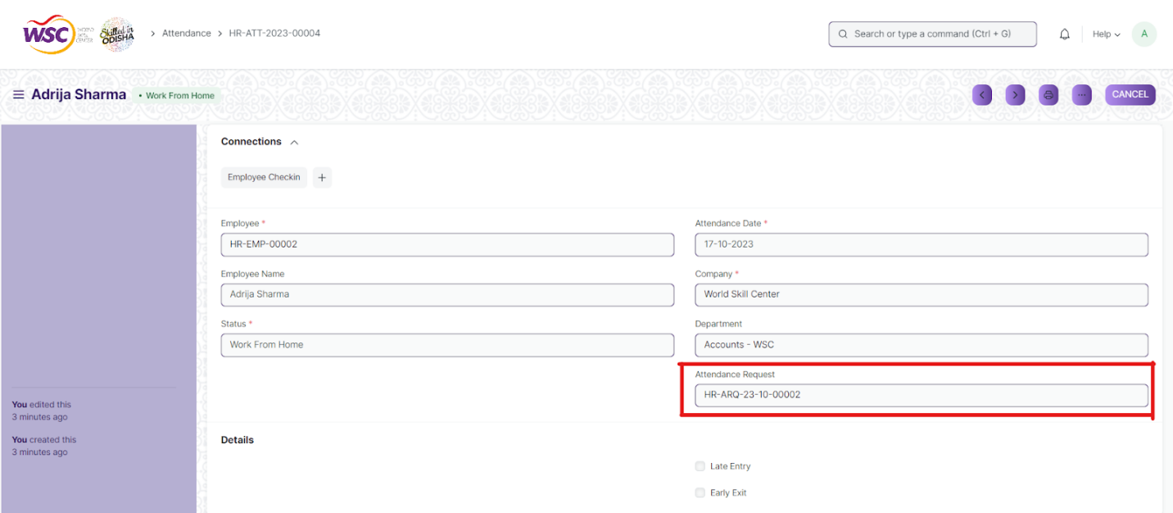

(Attendance Request  Record **HR-ARQ-23-10-00002** linked with Attendance **HR-ATT-2023-0004** )

On deletion of attendance request record  ,It will show the following message ,

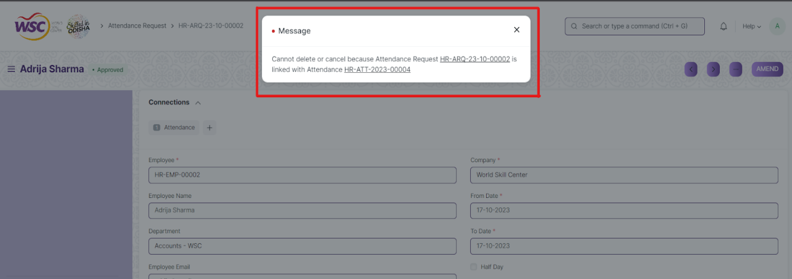

So go the following Attendance Request record document(**HR-ARQ-23-10-00002 )**, and cancel it first . After cancellation , user will able to delete the attendance record ( **HR-ATT-2023-0004)**.

**Note :** To initiate the cancellation process, kindly click on the link labeled **'HR-ARQ-23-10-00002**,' which corresponds to the attendance request record."

### Action Menu on a document.

The three dots menu, located in the right corner of a document in a Screen , offers a range of actions and options to manage and interact with the document.

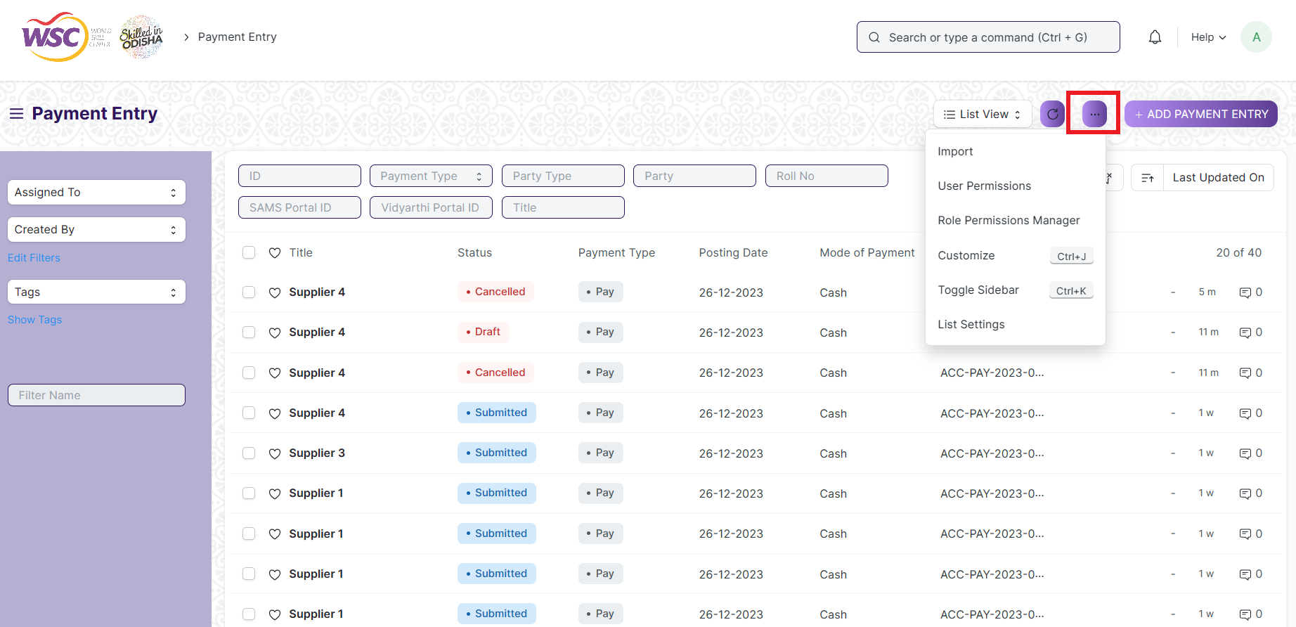

The functionalities available in the three dots menu are given below .

**Print :** Print Enables you to generate a printable version of the document ., which you can save as a PDF or send to a printer.

**Email :** Click on Email allows you to send the document as an attachment via email to specified recipients.

**Duplicate :** Create a new document with the same information as the current one.

**Delete :** Permanently remove the document.

**Cancel :** Cancel the submitted document.

**Submit :** Submit the document . If the document is submittable.

**Links :** This Option displays a list of document that are linked to the current document. You can navigate these linked documents from here.

**Jump to field :** You can directly go the required field by clicking this option and giving appropriate field name.

**Copy to Clipboard :** By clicking this option you can copy the content of the document .

**Rename :** By clicking the Rename option you can Rename the document.

**Note :** These options will be visible to employees who have necessary permission.

# Accounting Master :-

## Company :-

A company is a legal entity made up of an association of people for carrying on a commercial or industrial enterprise.

**>>> To access Company, go to :-**

Home >> Accounts >> Accounting Masters >> Company

**>>> How to create a Company :-**

1. Go to the ***Company*** list, click on ***+ Add New Company***

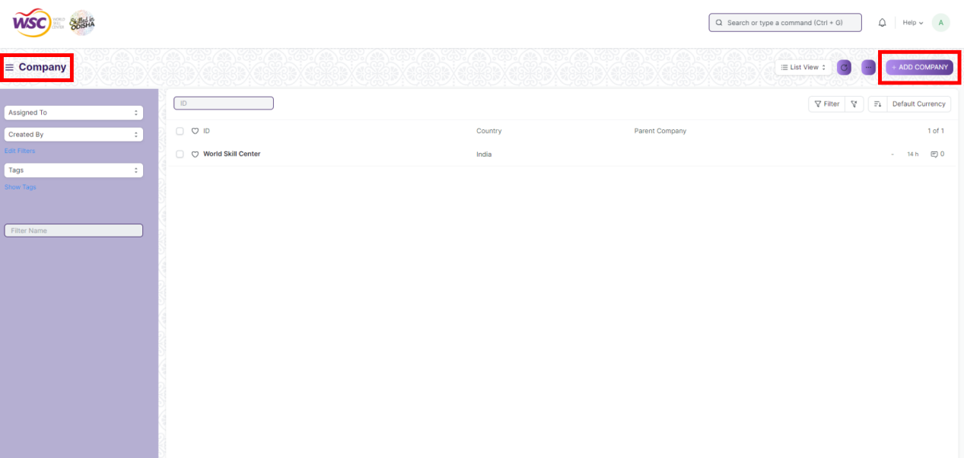

1. Enter ***Company***, ***Abbr.,*** ***Tax ID***, ***Domain.***
2. Select ***Default Currency***, ***Country***, ***Default Letter Head***, ***Date of Establishment***, ***Parent Company***, ***Default Holiday List***, ***Create Chart of Accounts Based On***.
3. Check ***Is Group*** check-box
4. Select ***Default Buying Terms***, ***Default Selling Terms***, ***Monthly Sales Target***, ***Default Warehouse for Sales Return***, ***Total Monthly Sales***, ***Default Employee Advance Account***, ***Round-off Account***, ***Default Payment Discount Account***, ***Round Off Cost Center***, ***Default Payment Terms Template***, ***Write Off Account***, ***Default Finance Book***, ***Exchange Gain / Loss Account***, ***Unrealized Exchange Gain/Loss Account***, ***Unrealized Profit / Loss Account***

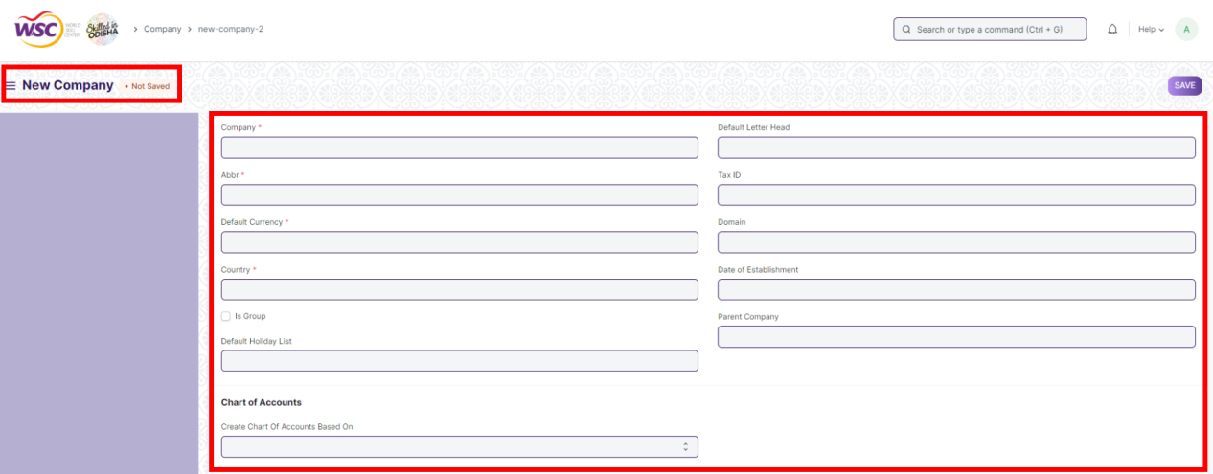

1. Click on ***Fixed Asset Default***
2. Select ***Accumulated Depreciation Account, Gain/Loss Account on Asset Disposal, Depreciation Expense Account, Asset Depreciation Cost Center, Series for Asset Depreciation Entry (Journal Entry), Capital Work In Progress Account, Expenses Included In Asset Valuation, Asset Received But Not Billed***

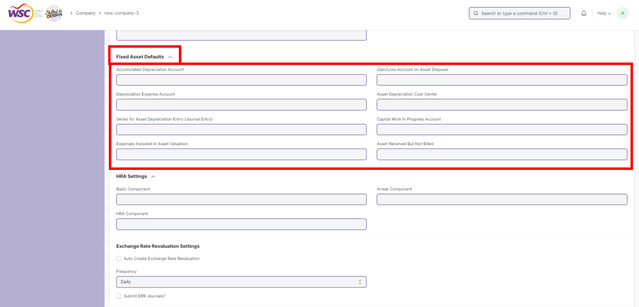

1. Click on ***HRA Setting***
2. Select ***Basic Component, Arrear Component, HRA Component***

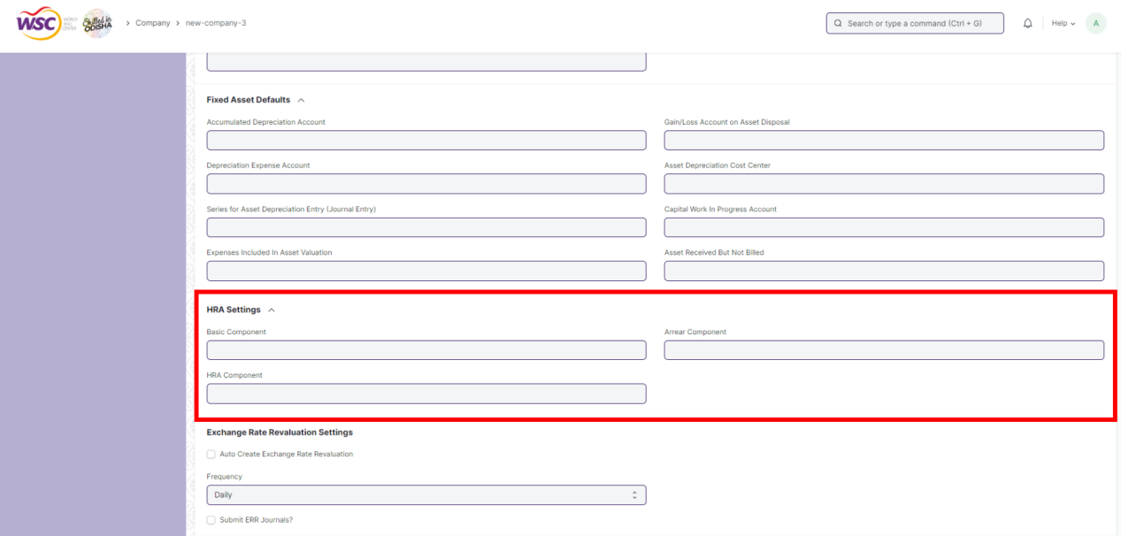

1. Check ***Auto Create Exchange Rate Revaluation*** check-box

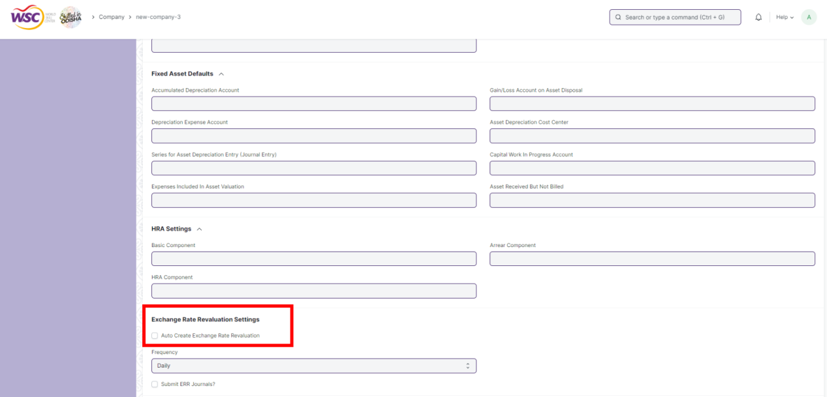

1. Select Frequency
2. Check ***Submit ERR Journals*** check-box

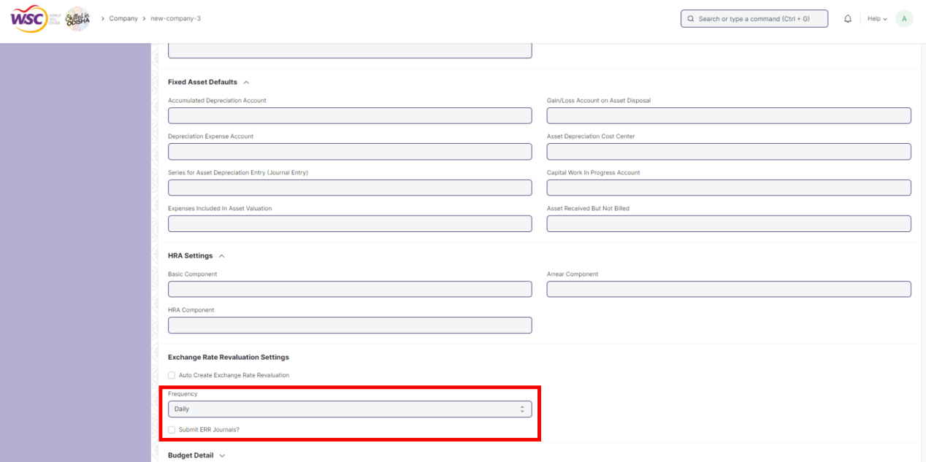

1. Click on ***Budget Details***
2. Select ***Exception Budget Approver Role***
3. Enter ***Registration Details***

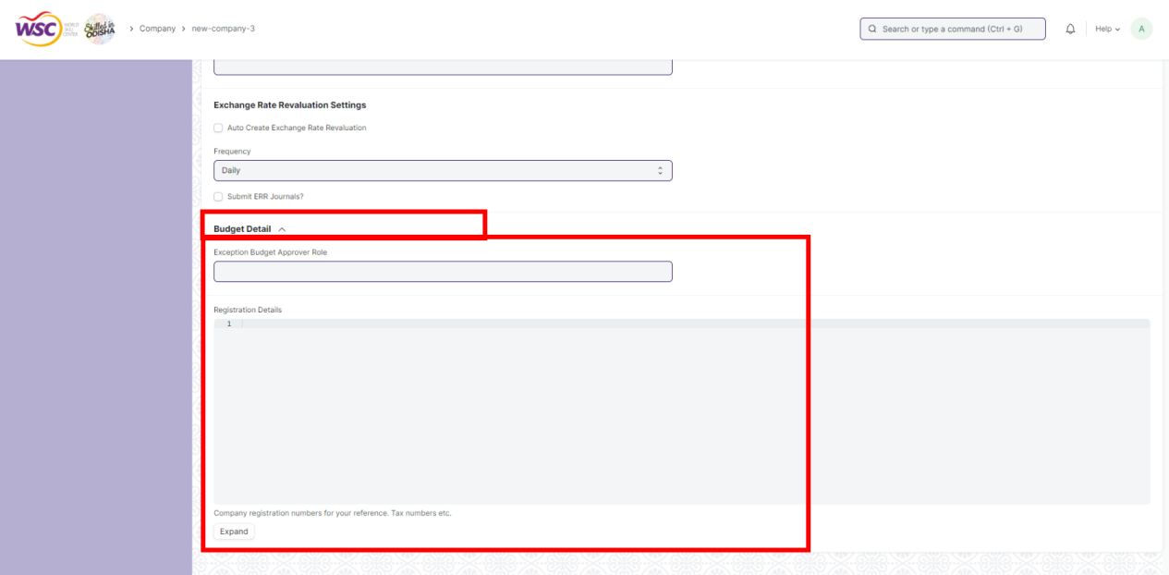

1. ***Save***

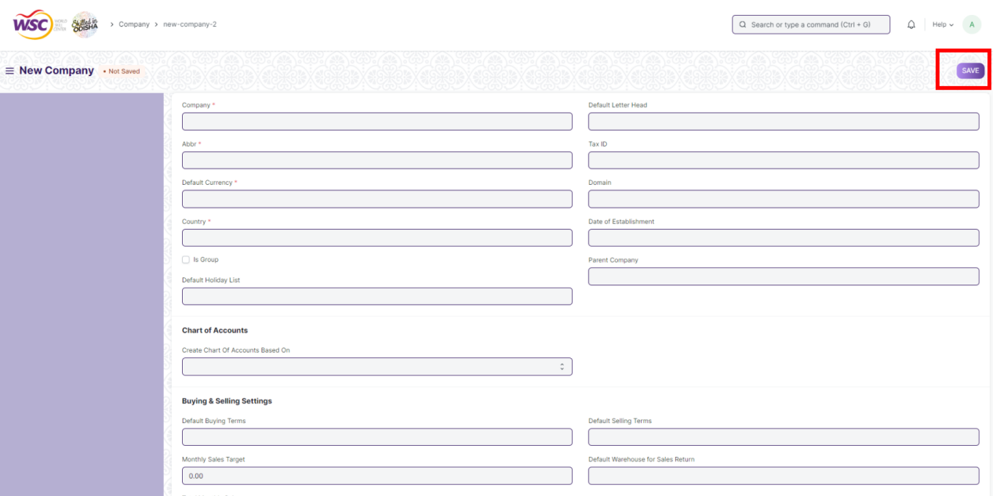

## Chart of Accounts :-

The Chart of Accounts is the blueprint of the accounts in your organization. The overall structure of your Chart of Accounts is based on a system of double entry accounting that has become a standard all over the world to quantify how a company is doing financially. Chart of Accounts is a tree view of the names of the Accounts (Ledgers and Groups) that a Company requires to manage its books of accounts.

**>>> To access Chart of Accounts, go to :-**

Home >> Accounts >> Accounting Master >> Chart of Accounts

**>>> How to create a Chart of Accounts :-**

1. Go to ***Chart of Accounts*** list, click on ***+ Add Account***

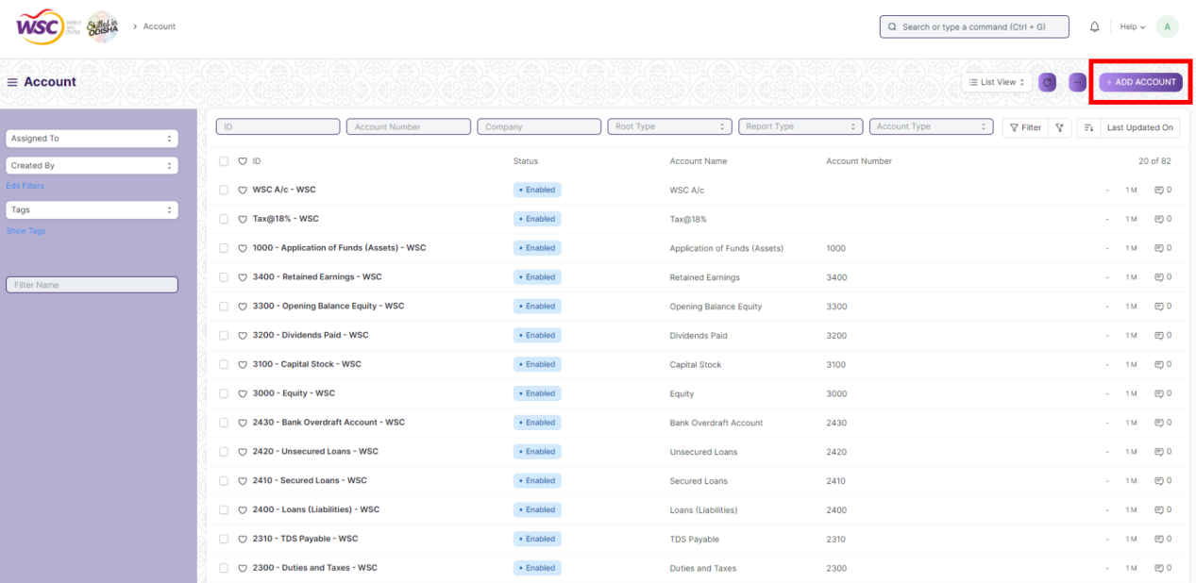

1. Check ***Disable*** check-box (if it has to be disabled.) Check ***Is Group*** *c*heck-box (if it is related to the group.)
2. Enter ***Account Name*** and ***Rate***
3. Select ***Parent Account***, ***Account Type***, ***Balance must be***
4. ***Save***

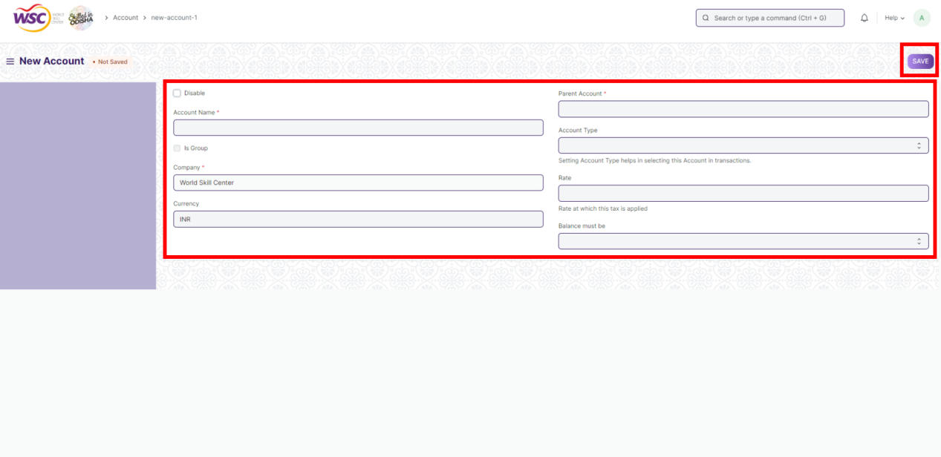

1. After saving ***Actions*** & ***View*** buttons will be visible. Click on ***Actions*** button if it is wanted to ***Merge Account*** or ***Update Account Name/Number*** or ***Convert into a group***. Click on ***View*** button if it is wanted to be viewed ***Chart of Account*** or ***General Ledger***.

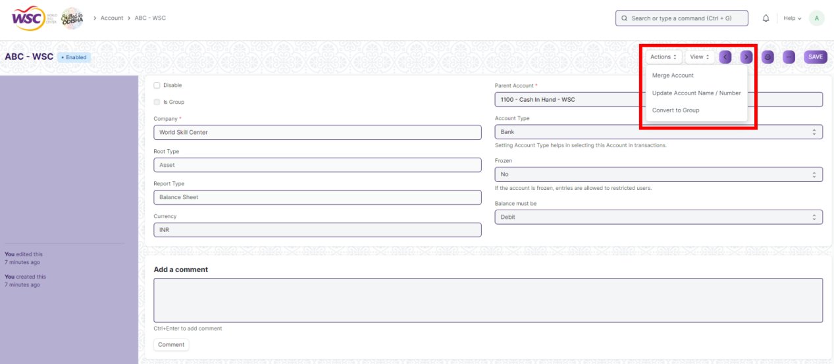

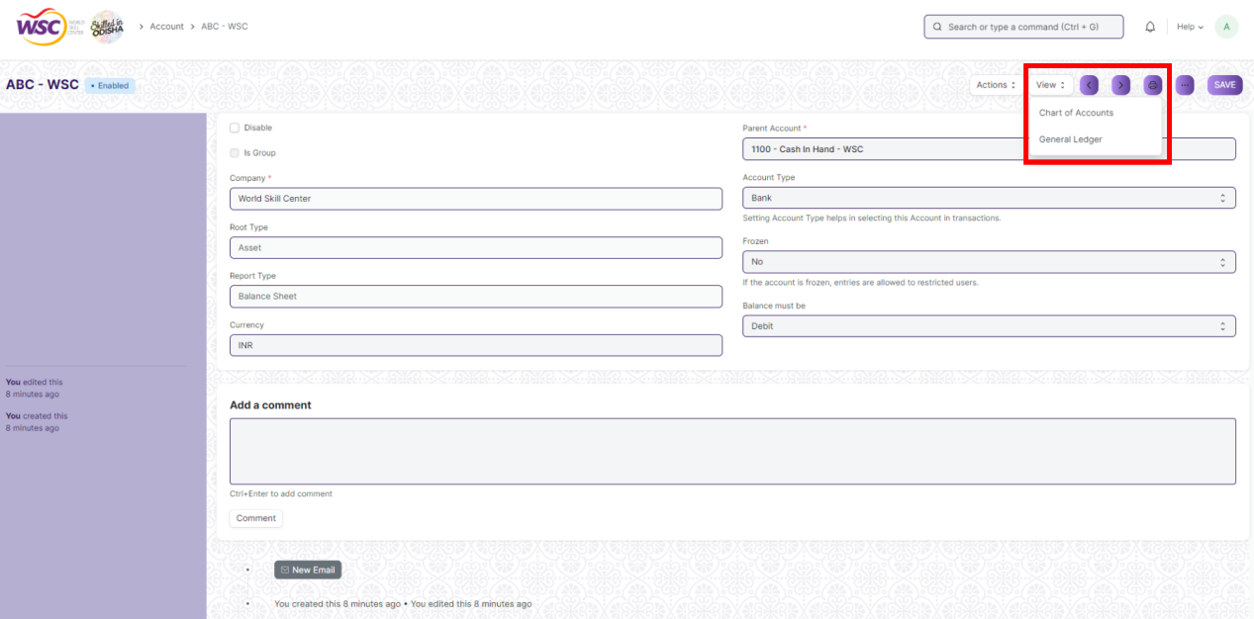

## Fiscal Year :-

A Fiscal Year is used to record and report the transactions for the year. It is also known as a financial year or a budget year. It is used for calculating financial statements in businesses and other organizations. The Fiscal Year may or may not be the same as a calendar year.

For tax purposes, companies can choose to be calendar-year taxpayers or fiscal-year taxpayers depending on the jurisdiction. In many jurisdictions, regulatory laws regarding accounting and taxation require such reports once per twelve months. However, it is not mandatory that the period should be a calendar year (that is, 1 January to 31 December).

A Fiscal Year usually starts at the beginning of a quarter, such as April 1, July 1 or October 1. However, most companies' Fiscal Year also coincides with the calendar year, which starts at January 1. For the most part, it is simpler and easier that way. For some organizations, there are advantages in starting the Fiscal Year at a different time.

**>>> To access Fiscal Year, go to :-**

Home > Account >> Accounting Master >> Fiscal Year

**>>> How to setup Fiscal Year :-**

1. Go to **Fiscal Year** list, click on ***+ Add Fiscal Year***

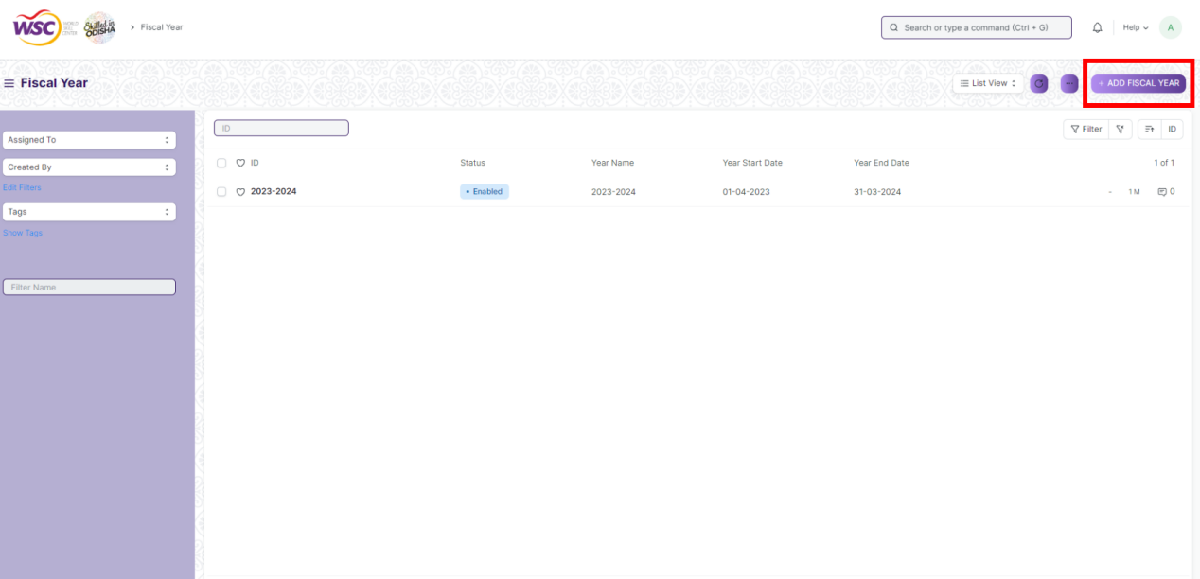

1. Enter ***Year Name***
2. Check ***Disabled*** if it is disabled
3. Click on ***Add Row*** to add company
4. ***Save***

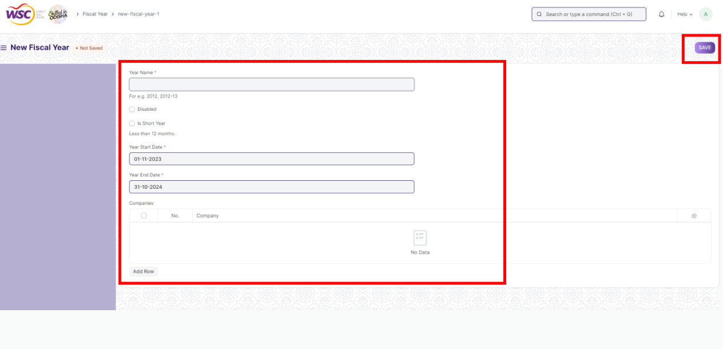

## Accounting Period :-

An Accounting Period defines a time period in which financial statements are recorded. Accounting Period is a time frame outside which selected submit-able transactions (like Sales/Purchase Invoice, Stock Entry, Payroll Entry, Journal Entry etc) are not allowed to be created. In other words, the selected transactions are only allowed to be created within the defined Accounting Period.

**>>> To access Accounting Period, go to :-**

Home >> Accounts >> Accounting Master >> Accounting Period

>>> **How to set up Accounting Period :-**

1. Go to ***Accounting Period*,** click on ***+ Add Accounting Period***

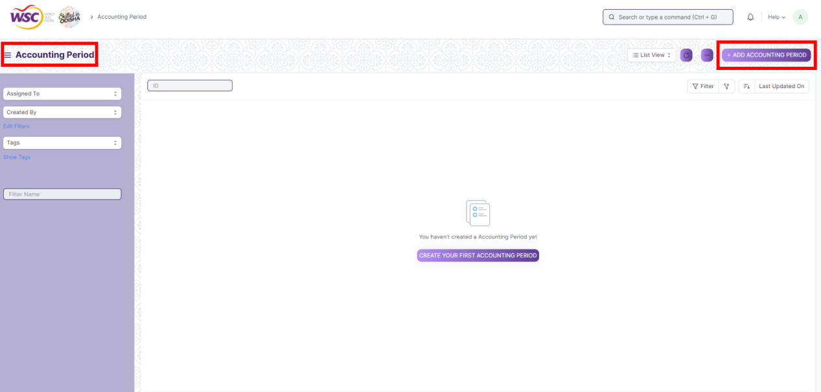

1. Enter ***Period Name*,** select ***Start Date*, *End Date***
2. ***Save***

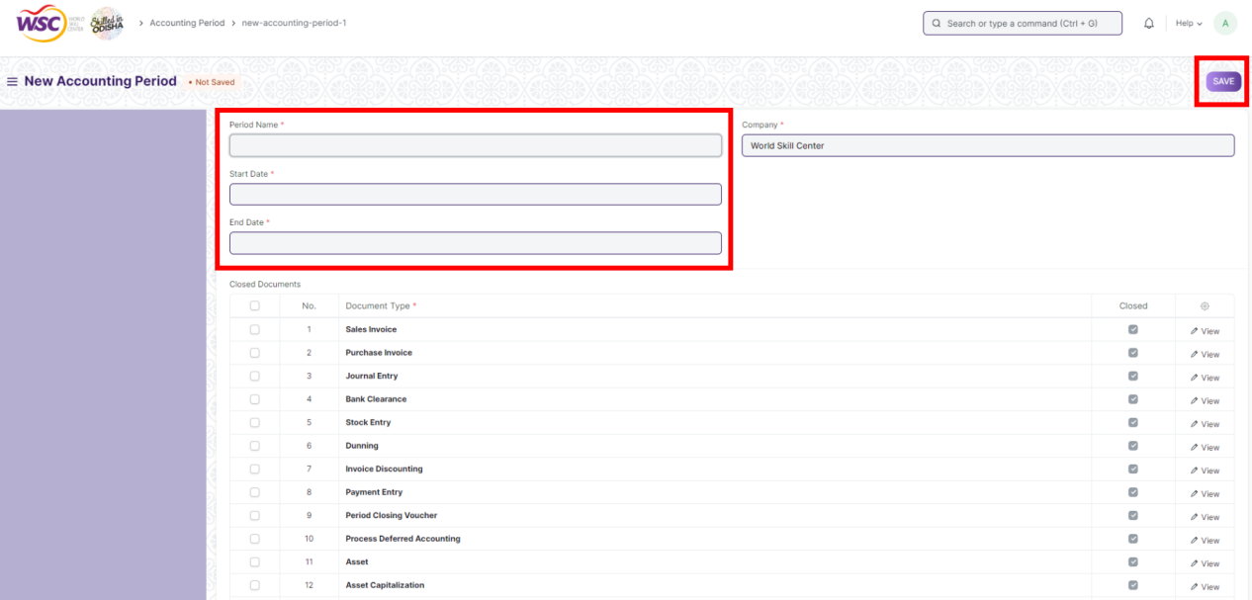

## Finance Book :-

A Finance Book is a book against which all the accounting entries are booked. You can have multiple finance books. For example, one book for tax authorities and another for stockholders. This is useful if you have to report depreciation and other values in different ways based on regulatory requirements. You can also use this to post alternate balance sheets for your internal reporting.

Finance Book is not a mandatory setup. But if you choose to create multiple Finance Books, then you can make entries against a specific Finance Book by selecting that book in Journal Entry. If a Finance Book field is blank in a Journal Entry that means the entry will be available in all finance books.

**>>> To access Finance Book, go to :-**

Home >> Accounts >> Accounting Master >> Accounting Period

>>> **How to set up Finance Book :-**

1. Go to ***Finance Book*,** click on ***+ Add Finance Book***

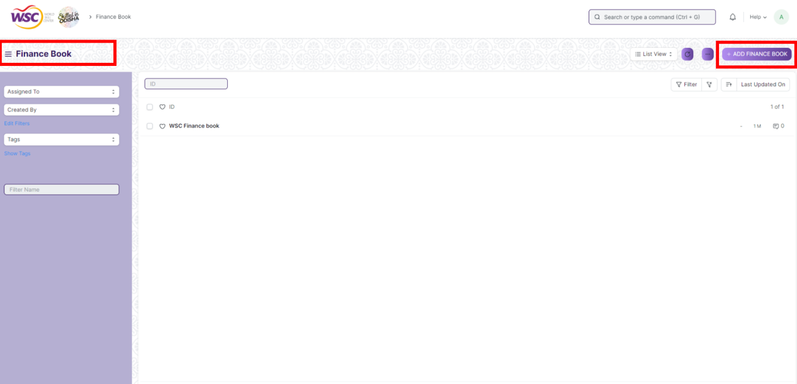

1. Enter ***Name***
2. ***Save***

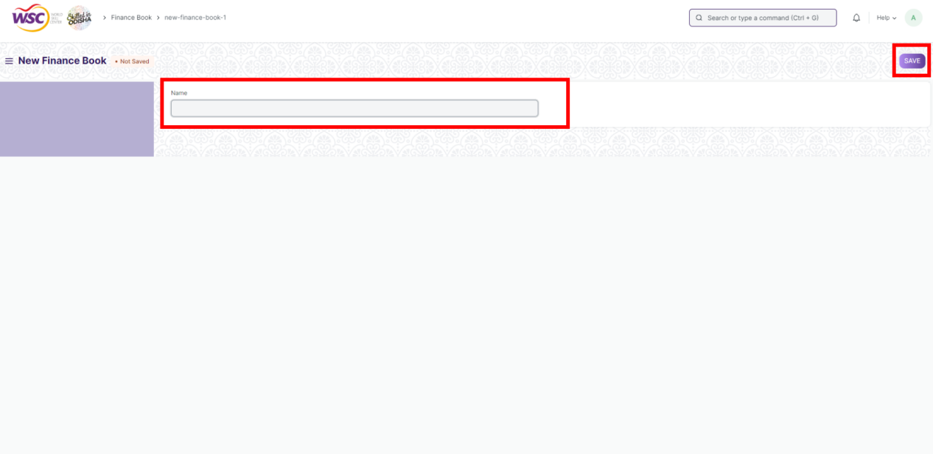

## Accounting Dimension :-

Dimensional accounting means tagging each transaction with appropriate dimensions like Branch, Business Unit, etc. This allows you to maintain each segment separately, thereby limiting the overall maintenance on GL accounts and your Chart of Accounts remains pure.

**>>> To access Accounting Dimension, go to :-**

Home >> Accounts >> Accounting Master >> Accounting Dimension

**>>> To create an Accounting Dimension :-**

1. Go to ***Accounting Dimension*** list**,** click on ***+ Add Accounting Dimension***

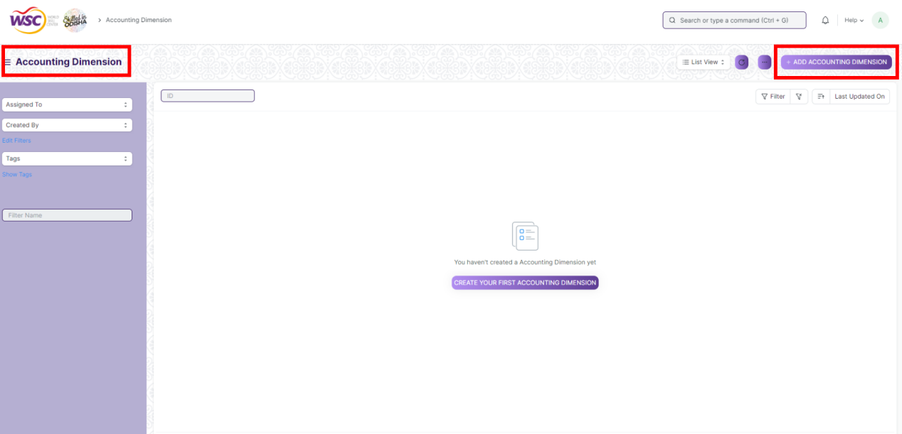

1. Select ***Reference Document Type***
2. Enter ***Dimension Name***
3. Click on ***Add Row*** & Enter ***Default Dimension***
4. Check ***Mandatory For Balance Sheet*** check-box if it is mandatory for balance sheet
5. Check ***Mandatory For Profit and Loss Account*** check-box if it is mandatory for profit & loss account
6. ***Save***

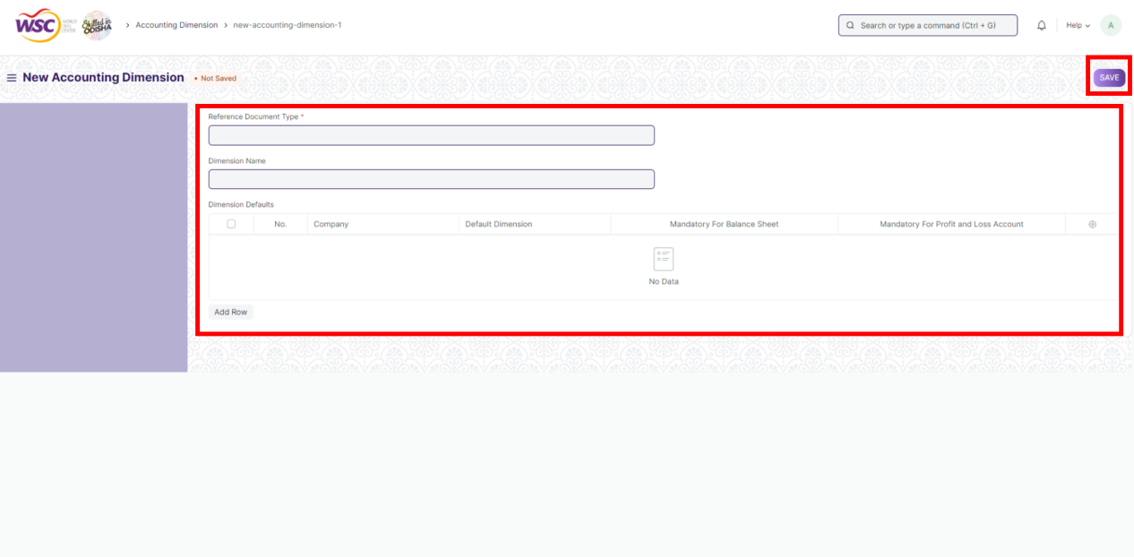

1. After saving two buttons ***show <reference document type> setting*** & ***Disable/Enable*** will be visible. Click on ***show <reference document type> setting*** button if it needs to be seen settings & click on ***Disable/Enable*** if it needs to be disabled or enabled.

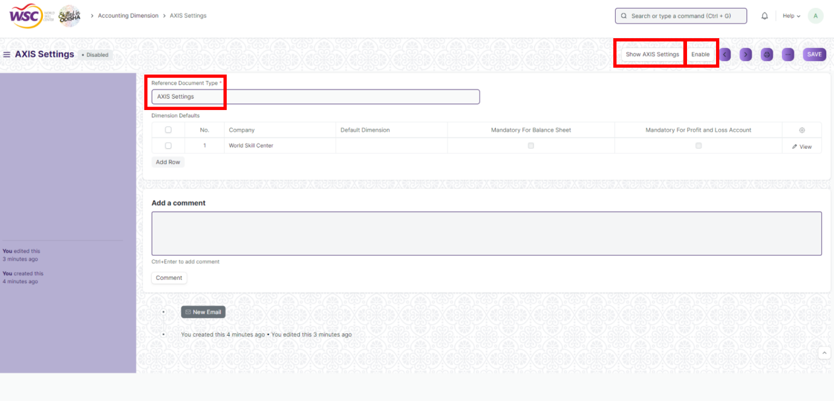

# General Ledger

## Journal Entry

**Description**

A Journal Entry is an entry made in the general ledger and it indicates the affected accounts.

To access the Journal Entry screen ,go to :

***Home>Accounts>General Ledger>Journal Entry***

**Screen**

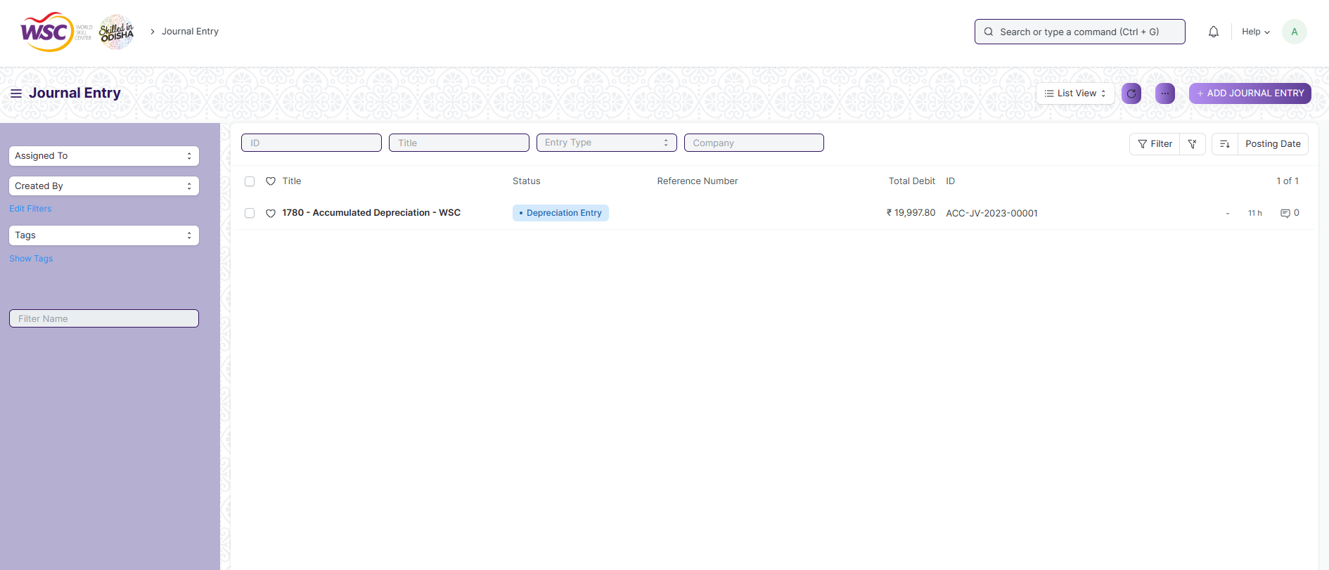

(List view of Journal Entry)

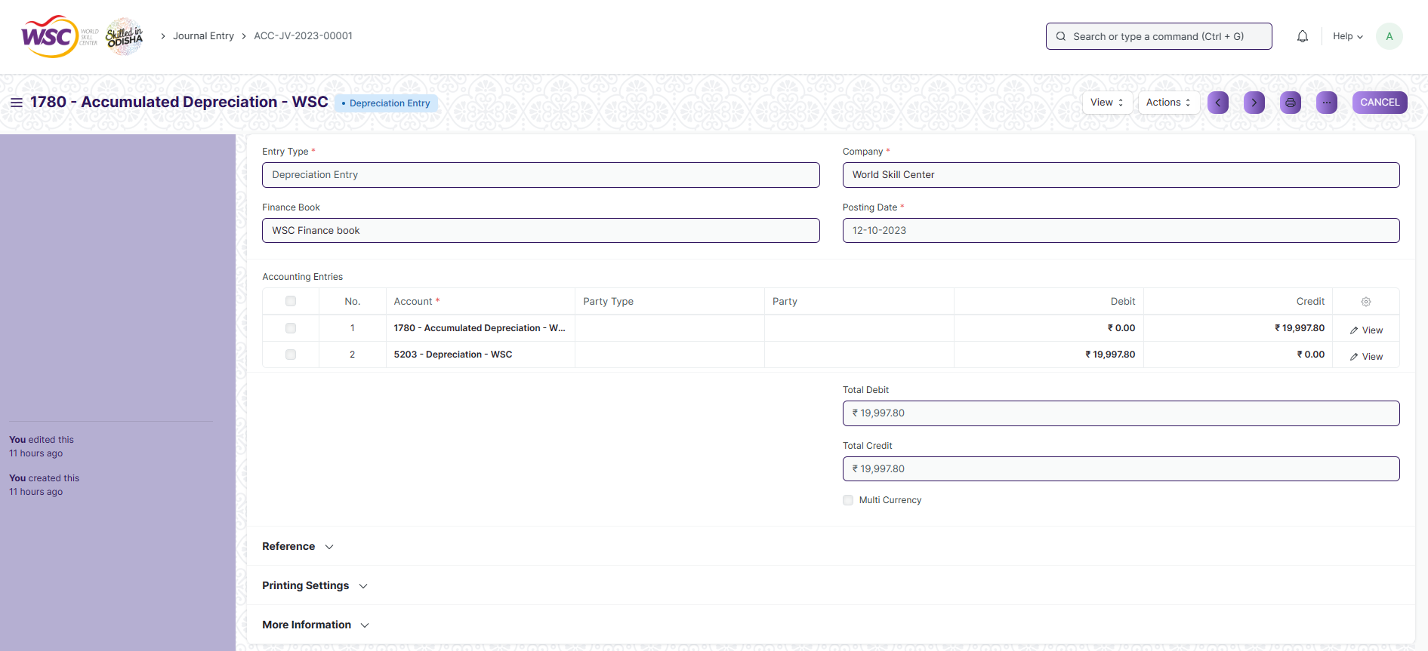

(View a saved record)

**Screen Type**

* Submittable

**Prerequisites**

* Company
* Finance Book
* Journal Entry Template
* Account
* Party Type
* Party
* Letter Head
* Print Heading
* Mode of Payment

**Adding a new record**

As it is a submittable screen, follow the general procedure to create a submittable document as mentioned above .

After creating a Journal Entry, the record will be visible in the List view of the screen.

**Deleting a record**

As it a submittable screen , follow the general procedure to delete a submittable document .

**Edit Record**

Follow the steps to view a saved Journal Entry.

Edit the field that you want to change.

If submitted, follow the general procedure to cancel and amend the document.

Click on Save.

**Print Record**

As it is a submittable screen , follow the general procedure to print a submittable document.

**View Record in different format**

As it is a submittable screen, follow the general procedure to view a submittable document in different format.

## General Ledger

**Description**

The General Ledger is a detailed report for all transactions posted to each account and for every transaction there is a Credit and Debit account so it lists them all up.

To access the General Ledger screen ,go to :

***Home>Accounts>General Ledger>General Ledger***

**Screen**

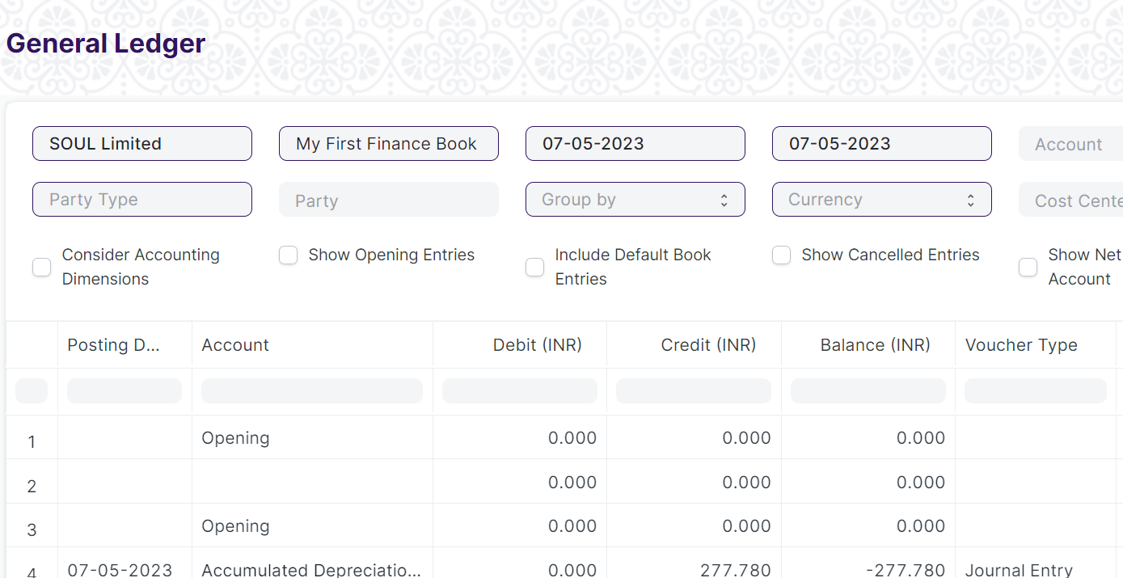

(View report)

**Screen Type**

* Report

**Prerequisites**

* Company
* Finance Book
* Account
* **Filters for From Date, To date, Company etc :**

Under filters assign fieldname, label, fieldtype, width, reqd and values for each of the filter values you want

## Supplier Ledger Summary

**Description**

This Shows the Ledger by Individual Supplier Wise.

To access the Supplier Ledger Summary screen ,go to :

***Home>Accounts>General Ledger>Supplier Ledger Summary***

**Screen**

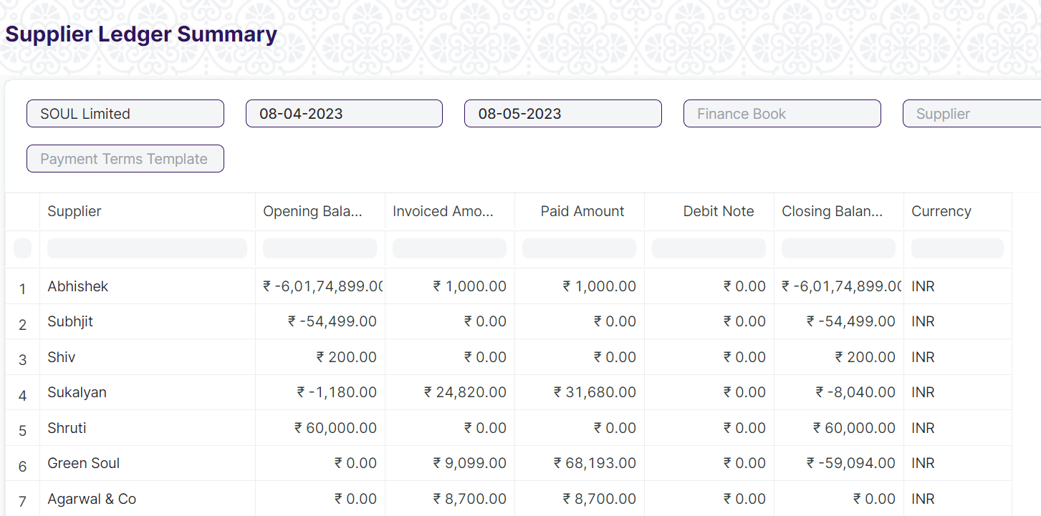

(View report)

**Screen Type**

* Report

**Prerequisites**

* Not Applicable
* **Filters for From Date, To date, Company etc :**

Under filters assign fieldname, label, fieldtype, width, reqd and values for each of the filter values you want

# Accounts Receivable

## Payment Entry

**Description**

Payment Entry is a record indicating that payment has been made for an invoice.

To access the Payment Entry screen ,go to :

***Home>Accounts>Accounts Receivable >Payment Entry***

**Screen**

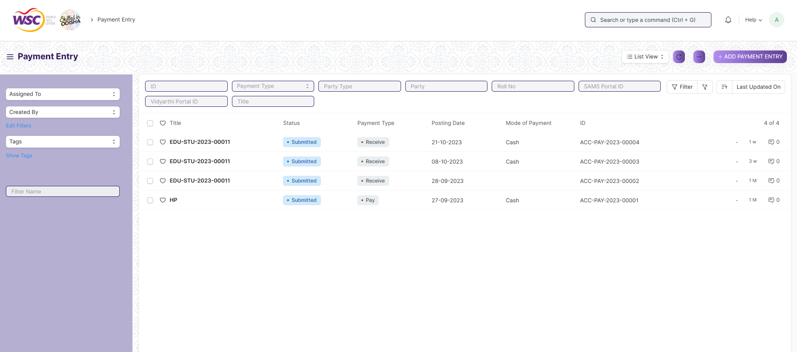

(List view of Payment Entry)

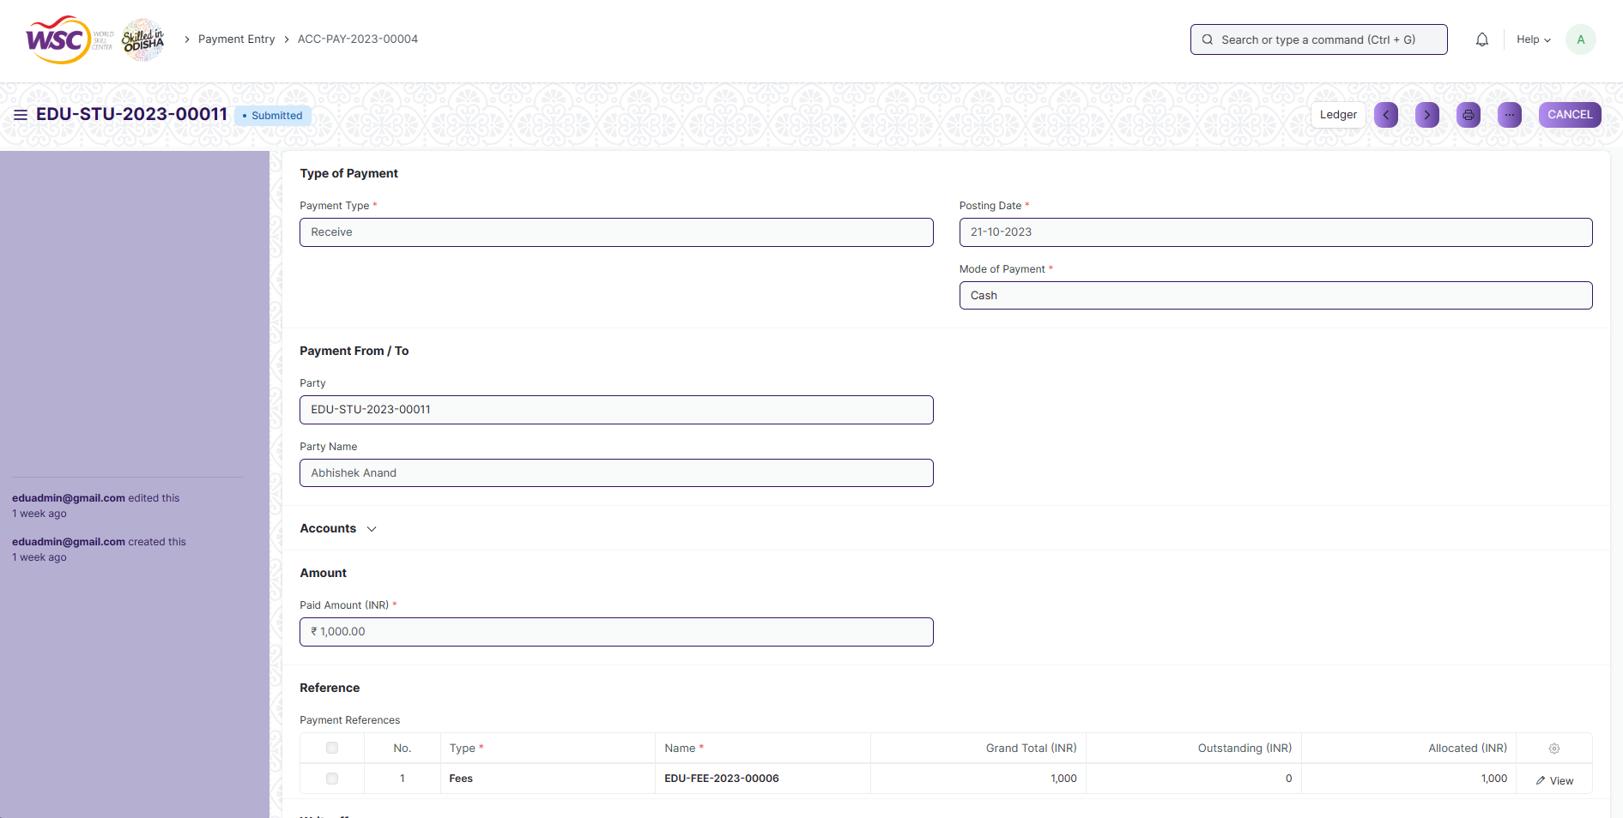

(View a saved record)

**Screen Type**

* Submittable

**Prerequisites**

* Mode of Payment
* Account
* Party Type
* Party
* Company
* Currency
* Tax Withholding Category
* Cost Center

**Adding a new record**

As it is a submittable screen, follow the general procedure to create a submittable document as mentioned above .

After creating a Payment Entry, the record will be visible in the List view of the screen.

**Deleting a record**

As it a submittable screen , follow the general procedure to delete a submittable document .

**Edit Record**

Follow the steps to view a saved Payment Entry.

Edit the field that you want to change.

If submitted, follow the general procedure to cancel and amend the document.

Click on Save.

**Print Record**

As it is a submittable screen , follow the general procedure to print a submittable document.

**View Record in different format**

As it is a submittable screen, follow the general procedure to view a submittable document in different format.

## Accounts Receivable

**Description**

This reports help you to track the outstanding amount of Students and other parties. It also provides ageing analysis i.e. a break-up of outstanding amount based on the period for which the amount is outstanding.

To access the Accounts Receivable screen ,go to :

***Home>Accounts>General Ledger>Accounts Receivable***

**Screen**

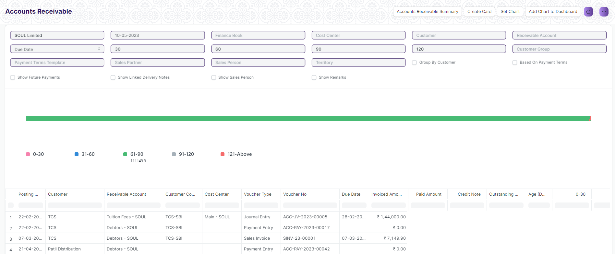

(View report)

**Screen Type**

* Report

**Prerequisites**

* Not Applicable
* **Filters for From Date, To date, Company etc :**

Under filters assign fieldname, label, fieldtype, width, reqd and values for each of the filter values you want

## Accounts Receivable Summary

**Description**

This reports help you to track the outstanding amount of Student and other parties. It also provides ageing analysis i.e. a break-up of outstanding amount based on the period for which the amount is outstanding.

To access the Accounts Receivable Summary screen ,go to :

***Home>Accounts>General Ledger>Accounts Receivable Summary***

**Screen**

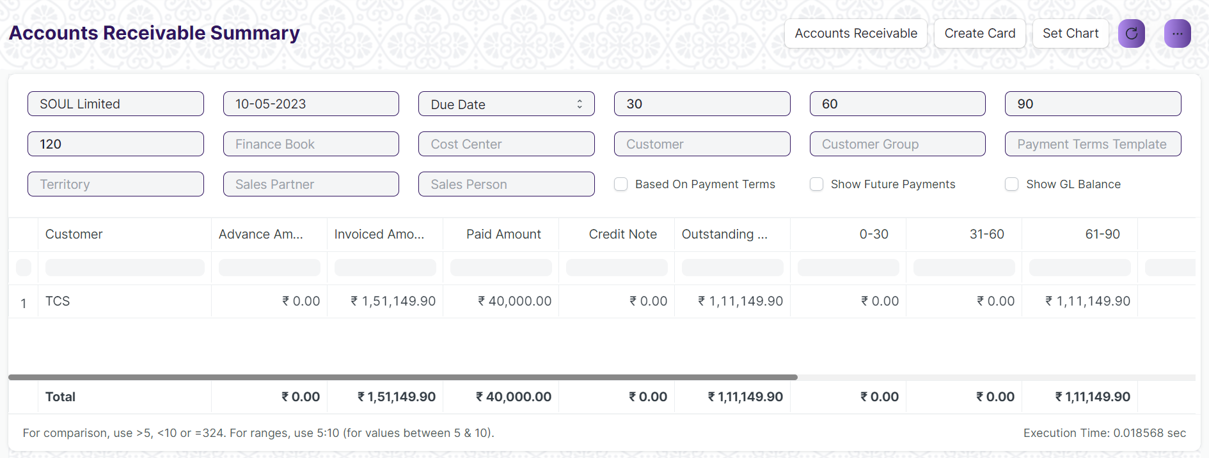

(View report)

**Screen Type**

* Report

**Prerequisites**

* Not Applicable
* **Filters for From Date, To date, Company etc :**

Under filters assign fieldname, label, fieldtype, width, reqd and values for each of the filter values you want

# Reports

## Trial Balance For Party

**Description**

It is common to review the trial balance for employees, students, and suppliers. This information can be easily accessed for all individuals or for specific individuals.

To access the Trial Balance for Party screen ,go to :

***Home>Accounts>Reports>Trial Balance for Party***

**Screen**

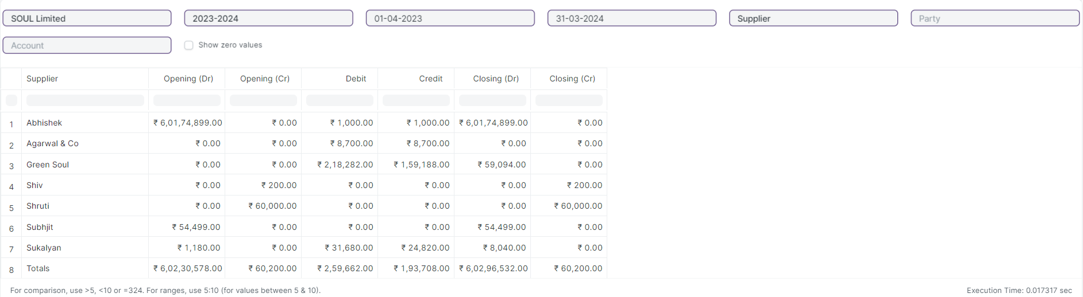

(View report)

**Screen Type**

* Report

**Prerequisites**

* Not Applicable
* **Filters for From Date, To date, Company etc :**

Under filters assign fieldname, label, fieldtype, width, reqd and values for each of the filter values you want

## Tax Detail

**Description**

Tax Details report provides an overview of all the taxes applied to transactions.This report shows the Item Tax Template, Taxes and Charges Template and Tax Category linked to various voucher types in the application.

To access the Tax Detail screen ,go to :

***Home>Accounts>Reports>Tax Detail***

**Screen**

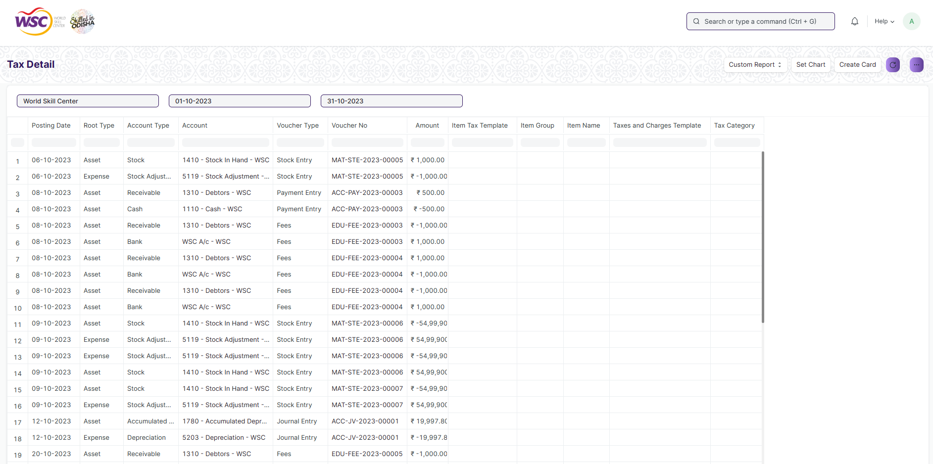

(View report)

**Screen Type**

* Report

**Prerequisites**

* Not Applicable
* **Filters for From Date, To date, Company etc :**

Under filters assign fieldname, label, fieldtype, width, reqd and values for each of the filter values you want

# Financial Statements

## Trial Balance

**Description**

A Trial Balance is an accounting report which lists account balances for all Accounts for any given reporting period. A company prepares a trial balance periodically, usually at the end of every reporting period. The general purpose of producing a trial balance is to ensure the entries in a company's bookkeeping system are mathematically correct. The totals of Debit and Credit columns must be same for any given period, to ensure the entries are correct.

To access the Trial Balance screen ,go to :

***Home>Accounts>Financial Statements>Trial Balance***

**Screen**

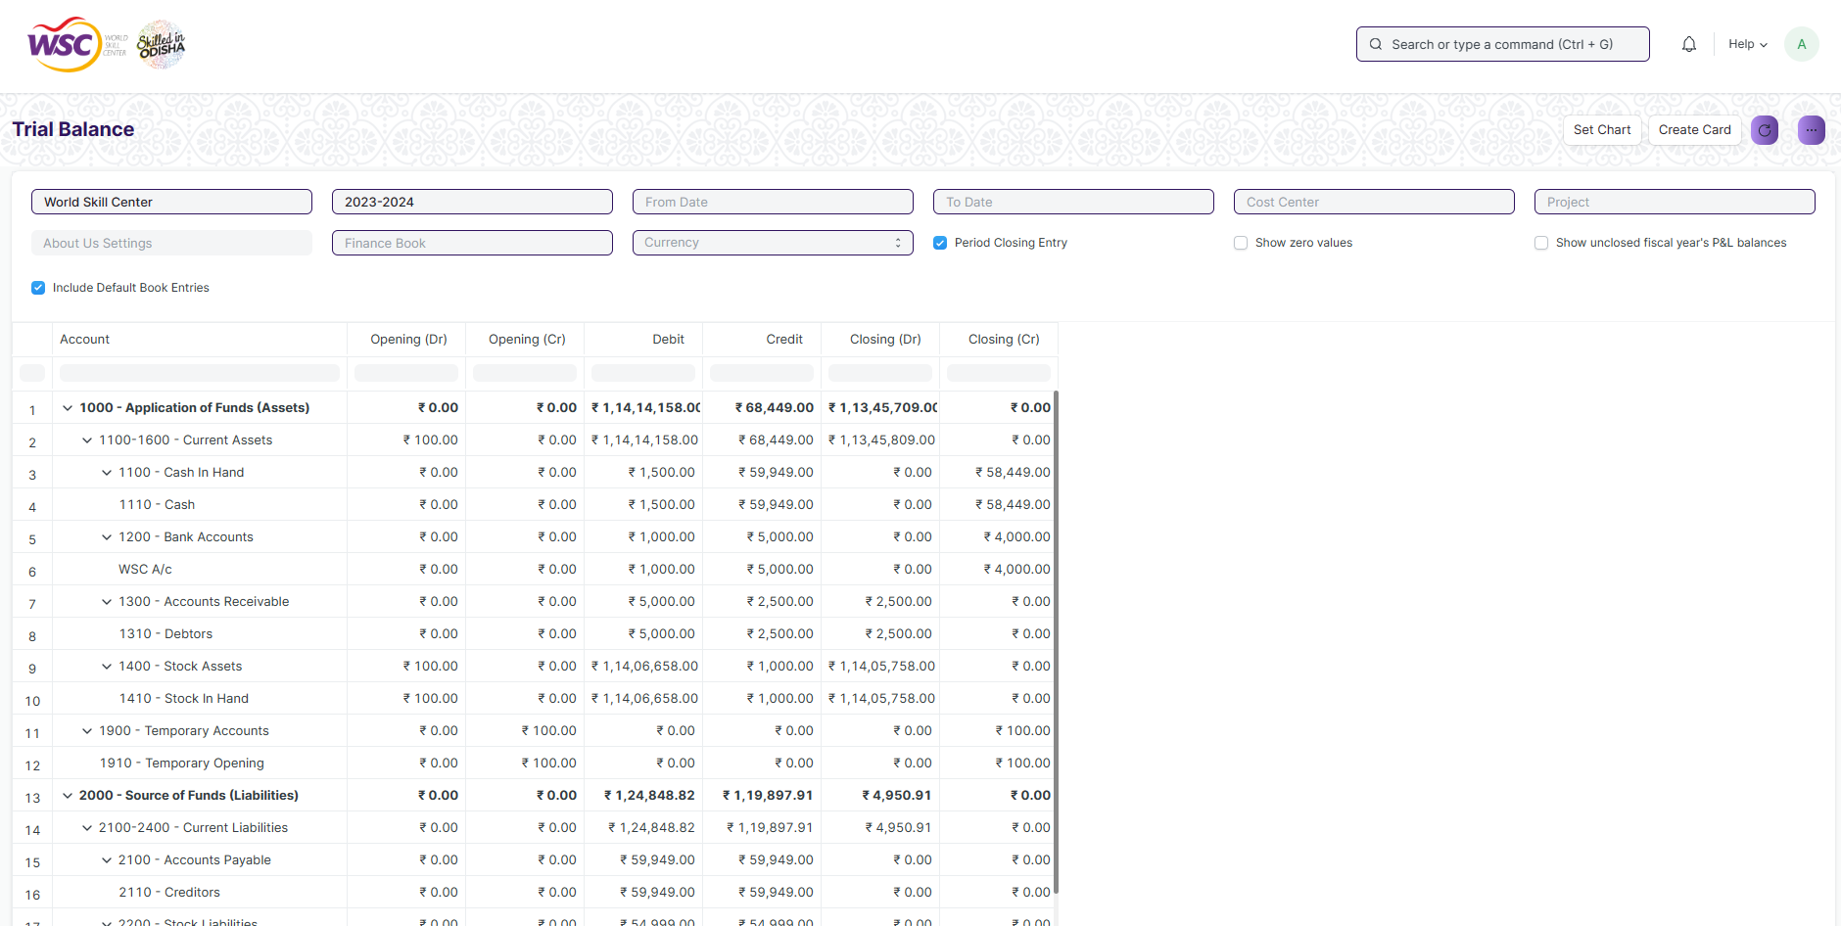

(View report)

**Screen Type**

* Report

**Prerequisites**

* Not Applicable
* **Filters for From Date, To date, Company etc :**

Under filters assign fieldname, label, fieldtype, width, reqd and values for each of the filter values you want

## Balance Sheet

**Description**

A Balance Sheet is the financial statement of a company which states assets, liabilities and equity at a particular point in time.

The Balance Sheet gives more flexibility to analyse your financial position. You can run the report across multiple year to compare values. You can check values for a specific Finance Book or Cost Center. You can also choose any other currency to display the balances.

To access the Balance Sheet screen ,go to :

***Home>Accounts>Financial Statements>Trial Balance***

**Screen**

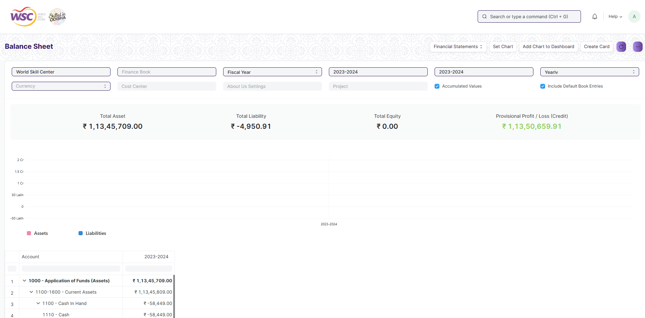

(View report)

**Screen Type**

* Report

**Prerequisites**

* Not Applicable
* **Filters for From Date, To date, Company etc :**

Under filters assign fieldname, label, fieldtype, width, reqd and values for each of the filter values you want

## Profit and Loss Statement

**Description**

A Profit and Loss Statement is a financial statement which summarizes all the revenues and expenses in a given period. The report is also known as P&L Statement.

To access the Profit and Loss Statement screen ,go to :

***Home>Accounts>Financial Statements>Profit and Loss Statement***

**Screen**

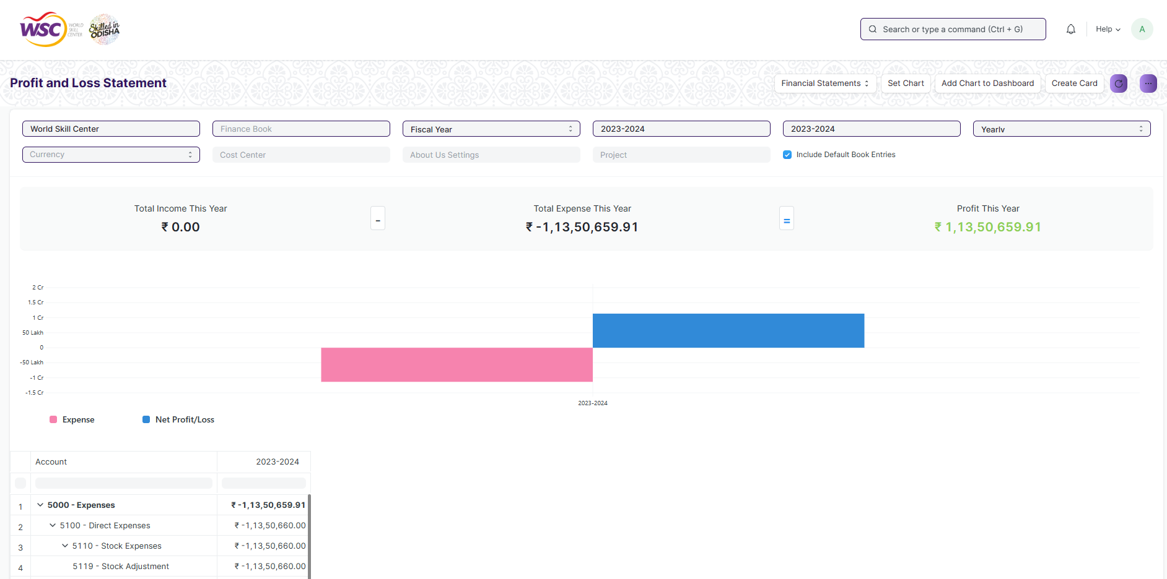

(View report)

**Screen Type**

* Report

**Prerequisites**

* Not Applicable
* **Filters for From Date, To date, Company etc :**

Under filters assign fieldname, label, fieldtype, width, reqd and values for each of the filter values you want

## Cash Flow

**Description**

A Cash Flow is a financial statement which shows the incoming and outgoing of cash or cash-equivalents for a company. It is used to analyse the liquidity position of the company.

To access the Cash Flow Statement screen ,go to :

***Home>Accounts>Financial Statements>Cash Flow***

**Screen**

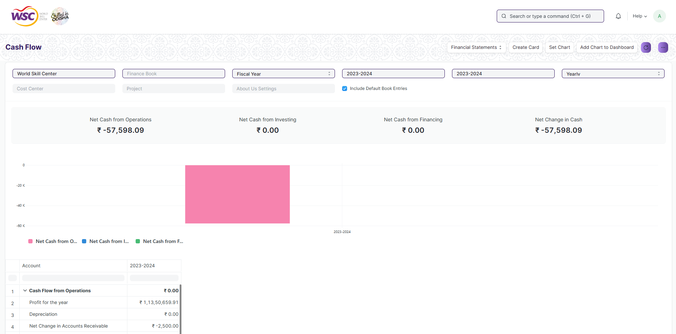

(View report)

**Screen Type**

* Report

**Prerequisites**

* Not Applicable
* **Filters for From Date, To date, Company etc :**

Under filters assign fieldname, label, fieldtype, width, reqd and values for each of the filter values you want

## Consolidated Financial Statement

**Description**

The report shows a consolidated view of Balance Sheet, Profit and Loss Statement and Cash Flow for a group company, by merging financial statements of all the subsidary companies. It shows balances for all individual company and as well as accumulated balances for a group company.

To access the Consolidated Financial Statement screen ,go to :

***Home>Accounts>Financial Statements>Consolidated Financial Statement***

**Screen**

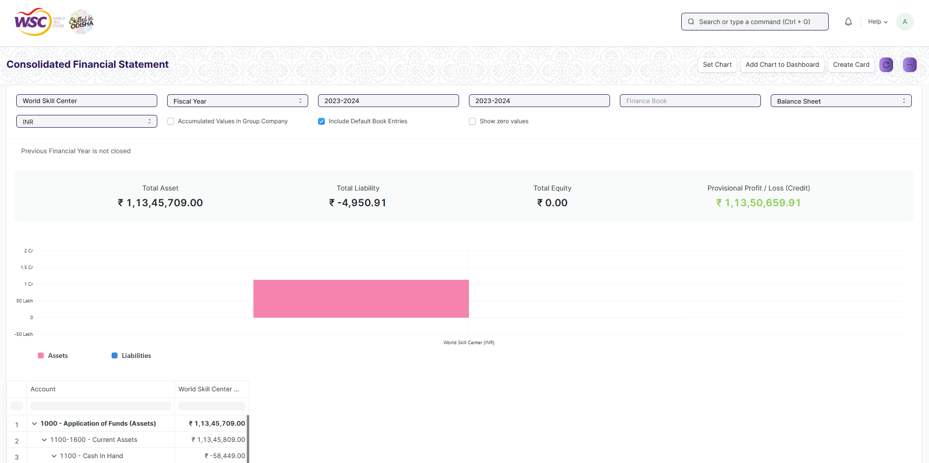

(View report)

**Screen Type**

* Report

**Prerequisites**

* Not Applicable
* **Filters for From Date, To date, Company etc :**

Under filters assign fieldname, label, fieldtype, width, reqd and values for each of the filter values you want

# Currency

## Currency

The Currency list stores the currency value, it's symbol and fraction unit. Most of the commonly used currencies are already present in the application.

To access the Currency screen ,go to :

***Home>Accounts>Multi Currency>Currency***

**Screen**

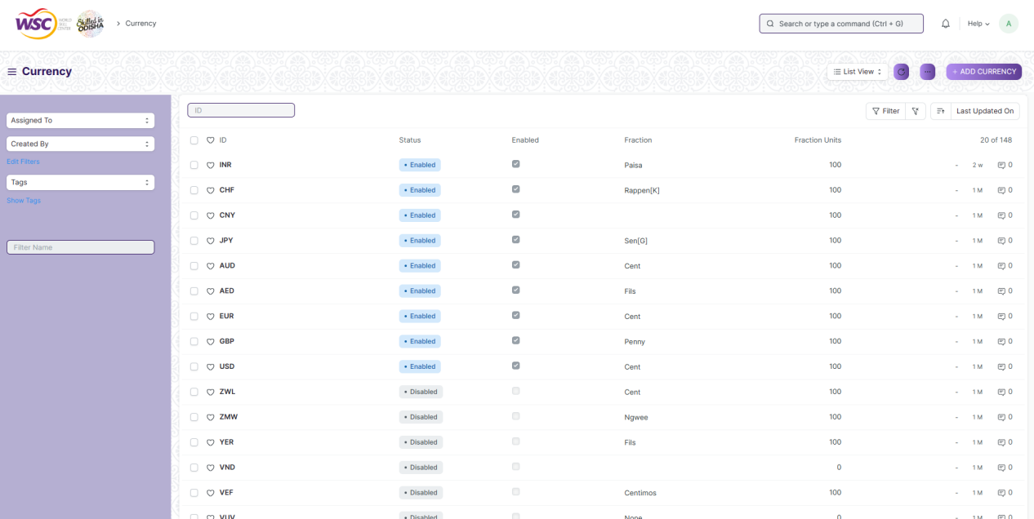

(List view of Currency)

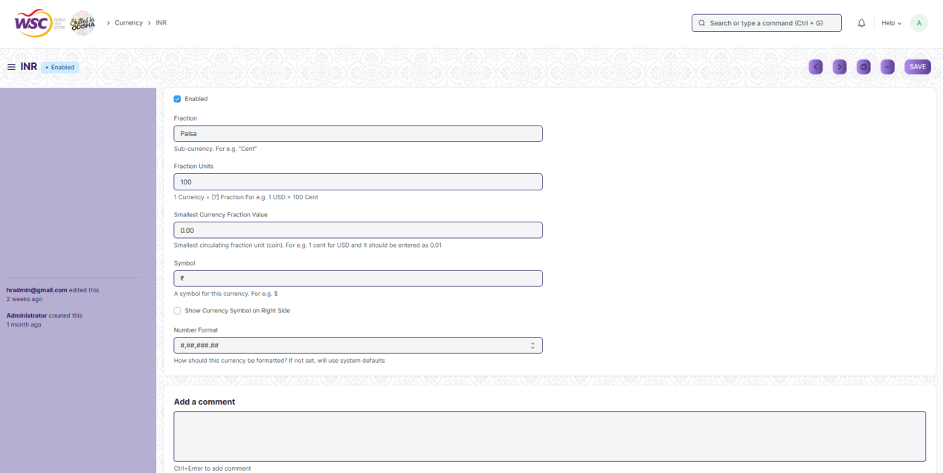

(View a saved record)

**Screen Type**

* Save

**Prerequisites**

* Not Available

**Adding a new record**

As it is a save screen, follow the general procedure to create a save document as mentioned above .

After creating a Currency, the record will be visible in the List view of the screen.

**Deleting a record**

As it a Save screen , follow the general procedure to delete a save document .

**Edit Record**

Follow the steps to view a saved Currency.

Edit the field that you want to change.

Click on Save.

**Print Record**

As it is a Save screen , follow the general procedure to print a saved document.

**View Record in different format**

As it is a Save screen , follow the general procedure to view a saved document in different format.

# Party

## Party Type

This can be Supplier or Student or Employee.

To access the Party Type screen search for Party Type in the Search bar.

**Screen**

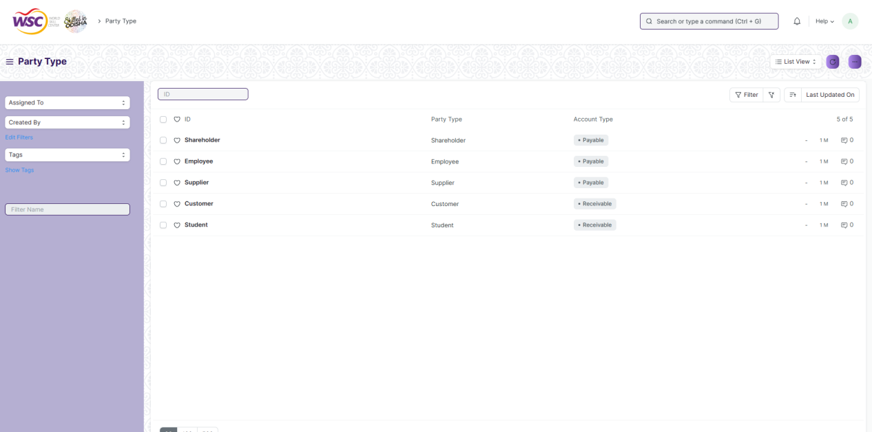

(List view of Party Type)

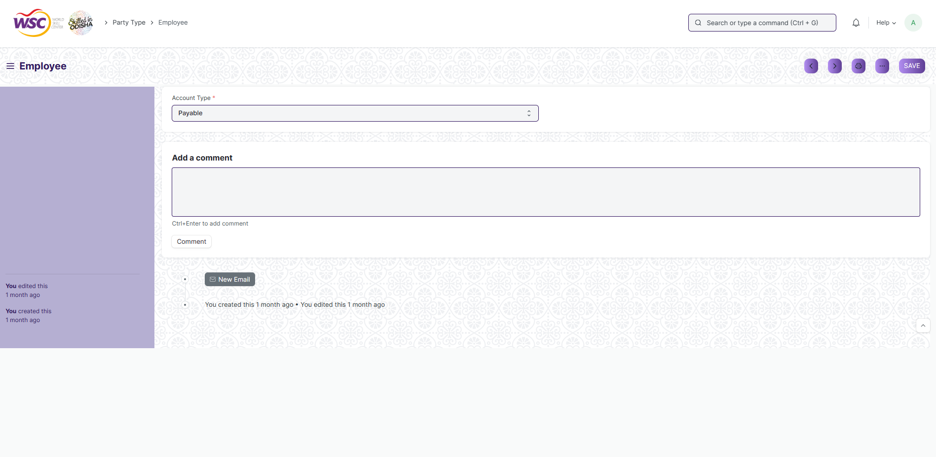

(View a saved record)

**Screen Type**

* Save

**Prerequisites**

* Not Available

**Adding a new record**

As it is a save screen, follow the general procedure to create a save document as mentioned above .

After creating a Party Type, the record will be visible in the List view of the screen.

**Deleting a record**

As it a Save screen , follow the general procedure to delete a save document .

**Edit Record**

Follow the steps to view a saved Party Type.

Edit the field that you want to change.

Click on Save.

**Print Record**

As it is a Save screen , follow the general procedure to print a saved document.

**View Record in different format**

As it is a Save screen , follow the general procedure to view a saved document in different format.

# Bank Statement

## Bank

A screen where information Bank information is stored , like Bank name,Account name details and address will be there.

To access the Bank screen ,go to :

***Home>Accounts>Bank Statement>Bank***

**Screen**

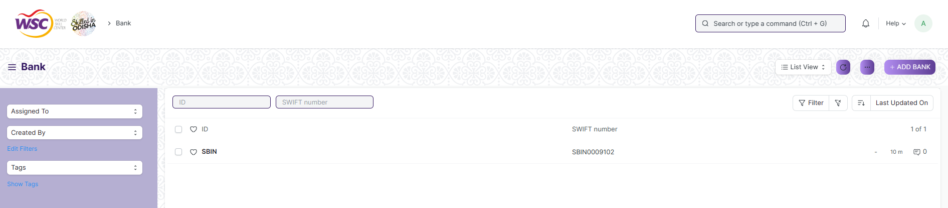

(List view of Bank)

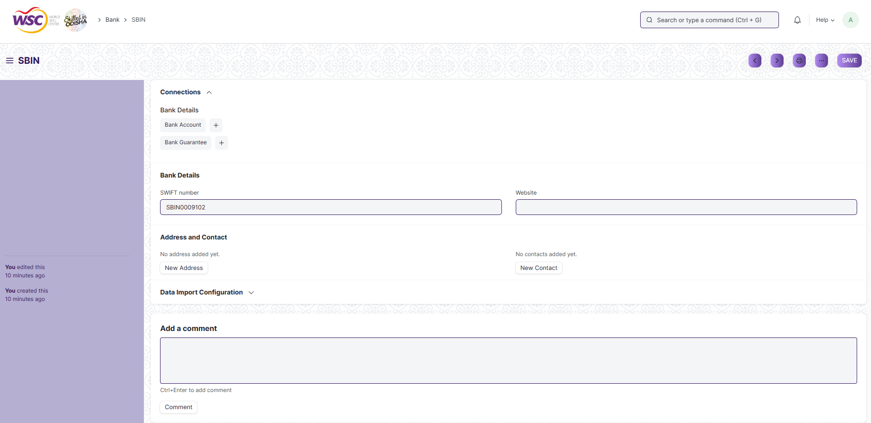

(View a saved record)

**Screen Type**

* Save

**Prerequisites**

* Not Available

**Adding a new record**

As it is a save screen, follow the general procedure to create a save document as mentioned above .

After creating a Bank , the record will be visible in the List view of the screen.

**Deleting a record**

As it a Save screen , follow the general procedure to delete a save document .

**Edit Record**

Follow the steps to view a saved Bank.

Edit the field that you want to change.

Click on Save.

**Print Record**

As it is a Save screen , follow the general procedure to print a saved document.

**View Record in different format**

As it is a Save screen , follow the general procedure to view a saved document in different format

## Bank Account

It is a screen where Bank Accounts can be created for a Company as well as other parties like Suppliers, Employee etc. Doing this lets you record all the bank transactions correctly for accounting accuracy.

To access the Bank Account screen ,go to :

***Home>Accounts>Bank Statement>Bank Account***

**Screen**

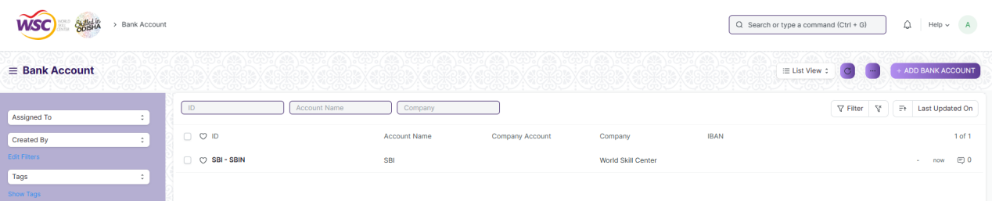

(List view of Bank Account)

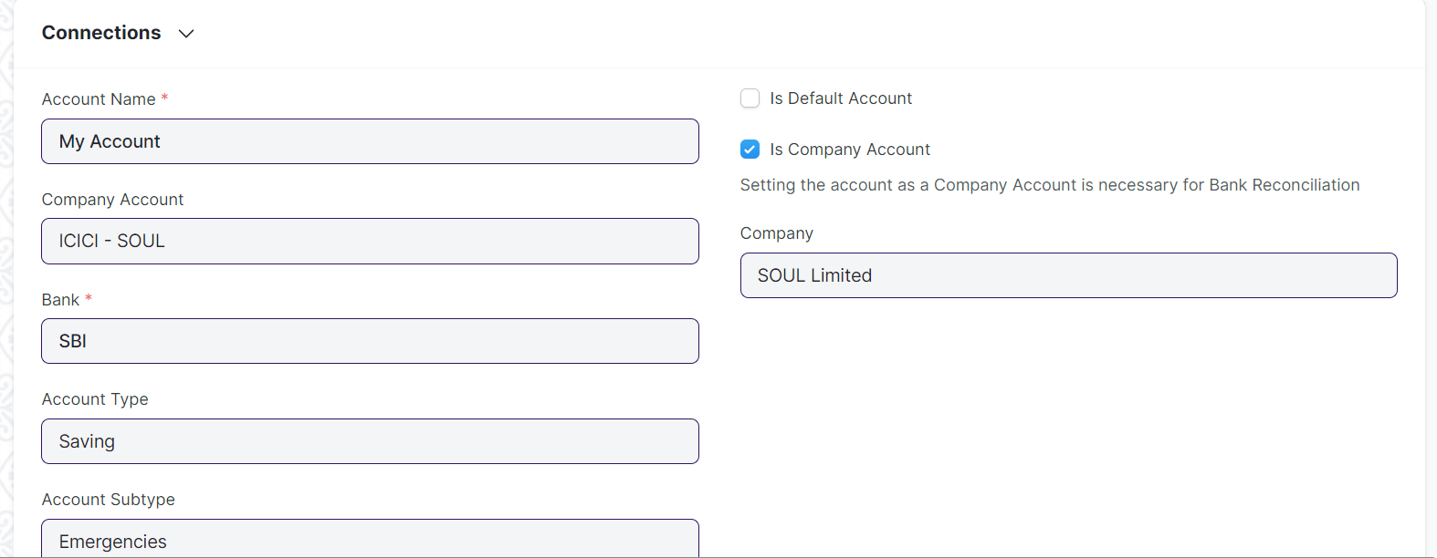

(View a saved record)

**Screen Type**

* Save

**Prerequisites**

* Bank

**Adding a new record**

As it is a save screen, follow the general procedure to create a save document as mentioned above .

After creating a Bank Account, the record will be visible in the List view of the screen.

**Deleting a record**

As it a Save screen , follow the general procedure to delete a save document .

**Edit Record**

Follow the steps to view a saved Bank Account.

Edit the field that you want to change.

Click on Save.

**Print Record**

As it is a Save screen , follow the general procedure to print a saved document.

**View Record in different format**

As it is a Save screen , follow the general procedure to view a saved document in different format.

## Bank Clearance

This feature is used to manually update clearance date with respect to payment entries which are not reconciled

To access the Bank Clearance screen ,go to :

***Home>Accounts>Bank Statement>Bank Clearance***

**Screen**

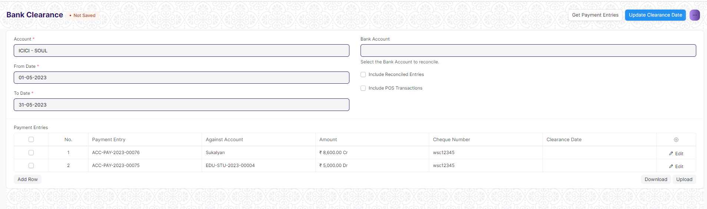

(View screen)

**Screen Type**

* Single screen

**Prerequisites**

* Payment Entries

**Usage**

This screen is used to add clearance date to multiple payment entries. Fill up the input fields correctly and click on the “Get Payment Entries” button on the top right side of the screen.

The payment entries(if any) will get fetched in the table.

Add the clearance date for each of the payment entries and click on the “Update Clearance Date” button in the top right corner of the screen.

The clearance date will be updated.

## Bank Reconciliation Tool

Once all your bank transactions are imported into the application, you can reconcile them with your existing vouchers.

The final goal of Bank Reconciliation is to make the difference amount zero (green) by either matching to an existing voucher or creating a new voucher.

To access the Bank Reconciliation Tool screen ,go to :

***Home>Accounts>Bank Statement>Bank Reconciliation Tool***

**Screen**

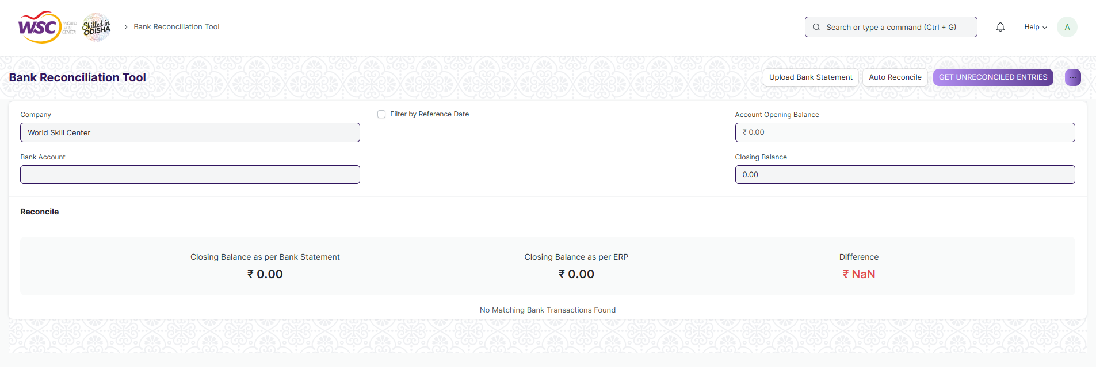

(View screen)

**Screen Type**

* Single screen

**Prerequisites**

* Payment Entries

**Usage**

This screen is used to Reconcile the Transactions in the system w.r.t. Bank Statement.

Fill up the relevant input fields and click on “Get Unreconciled Entries” button on the top right side of the screen. The unreconciled entries will be fetched.

Click on “Upload Bank Statement” button to upload the bank statement.

Click on “Auto Reconcile” button on the top right corner of the screen or reconcile each of the transactions manually.

## Bank Reconciliation Statement

**Description**

The Bank Reconciliation Report provides the difference between the bank balance shown in an organization's bank statement, as provided by the bank against the amount shown in the companies Chart of Accounts.

To access the Bank Reconciliation Statement screen ,go to :

***Home>Accounts>Bank Statement>Bank Reconciliation Statement***

**Screen**

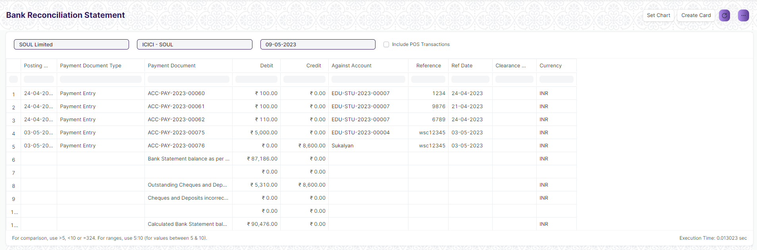

(View report)

**Screen Type**

* Report

**Prerequisites**

* Not Applicable
* **Filters for Date, Bank Account, Company etc :**

Under filters assign fieldname, label, fieldtype, width, reqd and values for each of the filter values you want

# Accounts Payable

## Accounts Payable :-

**>>> To access Account Payable, go to :-**

Home >> Accounts >> Accounting Payable >> Accounting Payable

**>>> To create Account Payable :-**

1. Go to Account Payable list, click on ***+ Add Account Payable***

2. Select ***Company, Posting Date, Finance Book, Cost Center, Supplier, Payable Account, Ageing Based On (Posting Date / Due Date / Supplier Invoice Date), Ageing Range 1, Ageing Range 2, <Reference Document Type> Setting, Ageing Range 3, Ageing Range 4, Payment Terms Template, Supplier Group***.

3. Check ***Group By Supplier, Based On Payment Terms, Show Remarks, Show Future Payments*** check-boxes as per requirement.

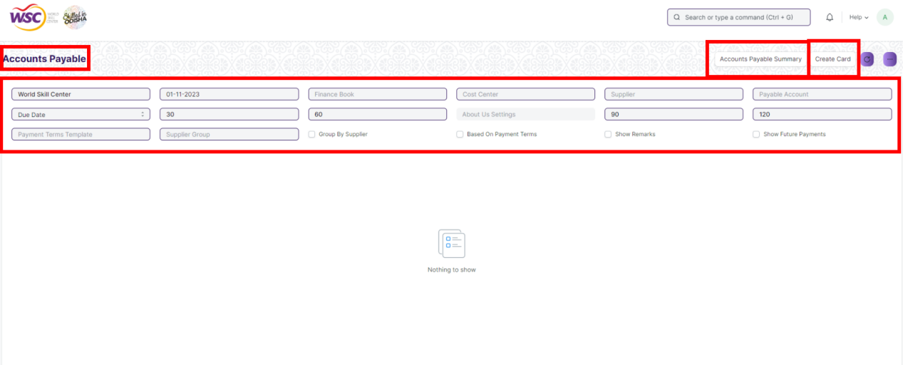

## Accounts Payable Summary :-

**>>> To access Account Payable, go to :-**

Home >> Accounts >> Accounting Payable >> Accounting Payable Summary

**>>> To create Account Payable Summary :-**

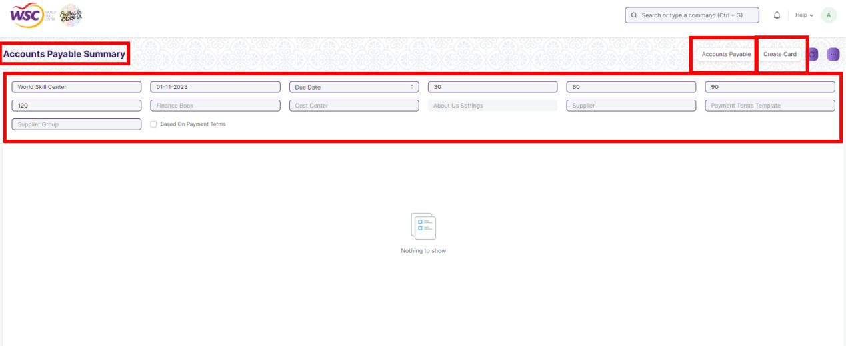

## Purchase Register :-

**>>> To access Account Payable, go to :-**

Home >> Accounts >> Accounting Payable >> Purchase Register

**>>> To create Purchase Register :-**

1. Go to ***Purchase Register***

2. Slect ***From Date, To Date, Supplier, Company, Mode of Payment, Cost Center, Store, <Reference Document Type> Setting, Item Group*** as filters & click on ***Create Card***

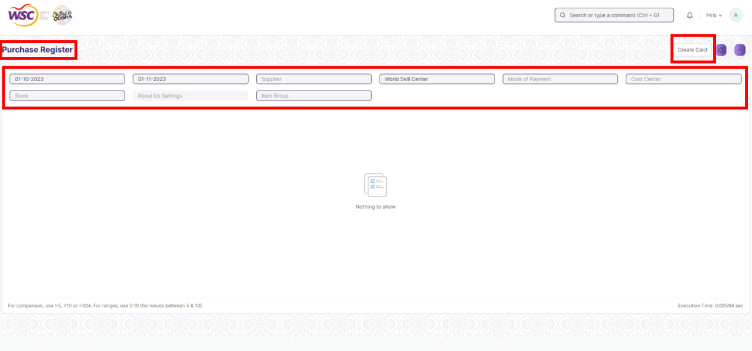

## Item-wise Purchase Register :-

**>>> To access Item-wise Purchase Register, go to :-**

Home >> Accounts >> Accounting Payable >> Item-wise Purchase Register

**>>> To create Item-wise Purchase Register :-**

1. Go to ***Item-wise Purchase Register***

2. Select ***From Date, To Date, Item, Supplier, Company, Mode of Payment, Group By*** as filters & click on ***Create Card.***

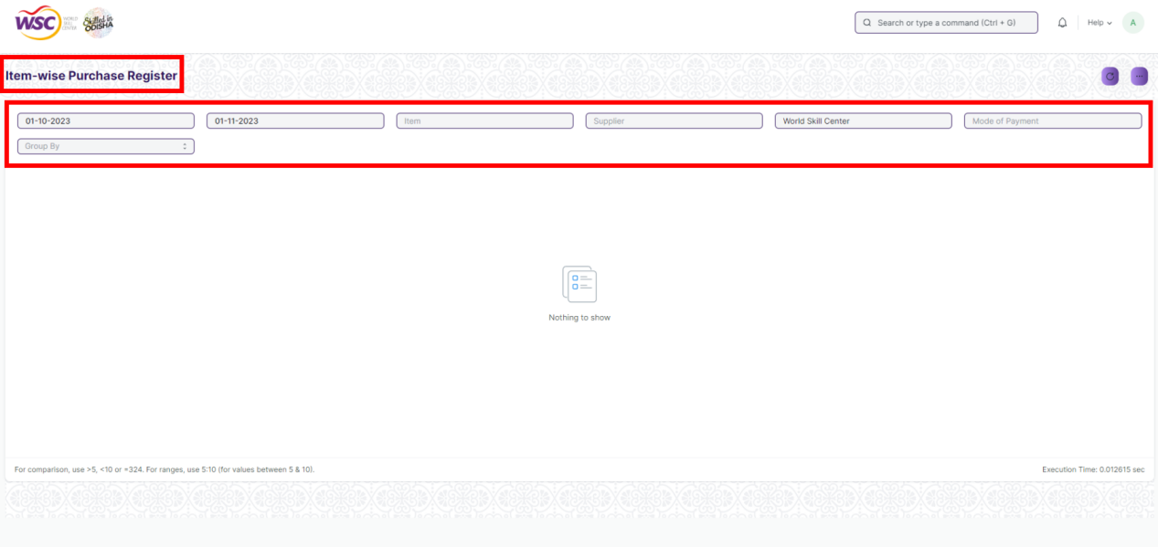

# Mode of Payment :-

In the sales and purchase transactions, there are various options to settle the payment. We can do it in cash, via bank transfer, via promotion voucher to list a few. In ERPNext, you can create Mode of Payments as per your requirement. In the Payment Entry, you can select the Mode of Payment applicable.

**>>> To access Mode of Payment, go to :-**

Home >> Accounts >> Settings >> Mode of Payment

**>>> To set-up Mode of Payment**

1. Go to Mode of Payment, click on ***+ Add Mode of Payment***

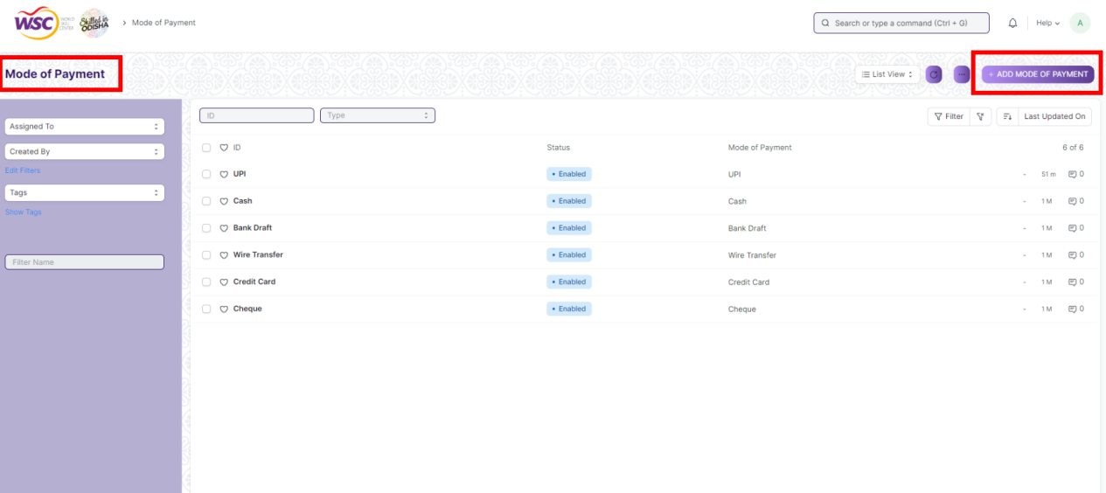

2. Enter ***Mode of Payment***

3. ***Save***

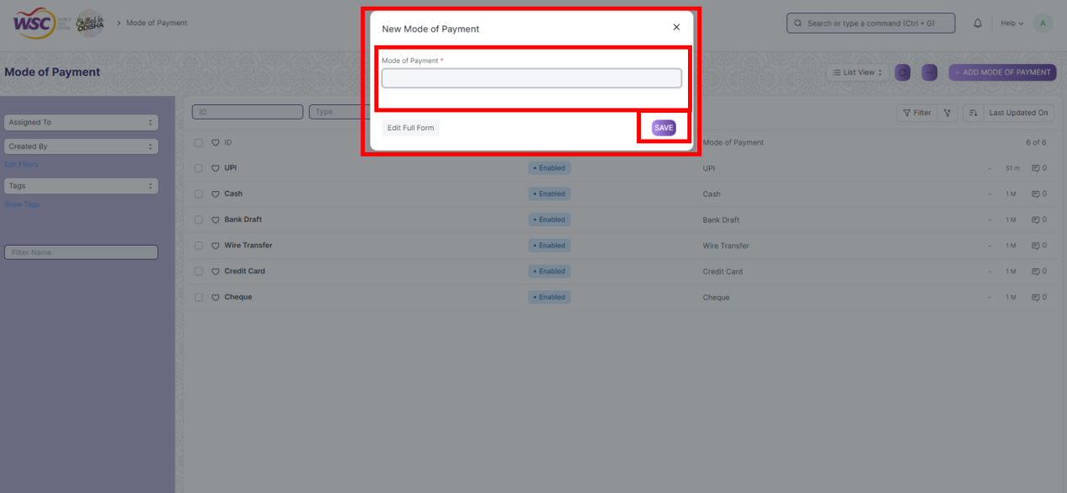

4. After saving click on the same Mode of Payment Screen from the list

5. Go to ***Accounts*** table, click on ***View*** button, ***Add Company*** & ***Default Account***

***6. Save***

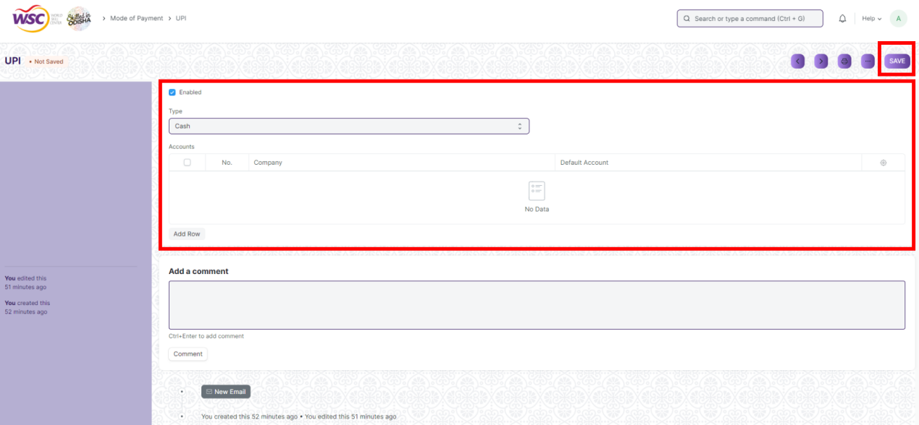

# Cost Center :-

A Cost Center is a part of an organization where costs or income can be charged. It can be used as Profit Center

**>>> To access Cost Center, go to :-**

Home >> Accounts >> Cost Center >> Chart of Cost Centers

**>>> To create Cost Center**

1. Go to ***Chart of Cost Centers***, click on ***+ Add Cost Center***

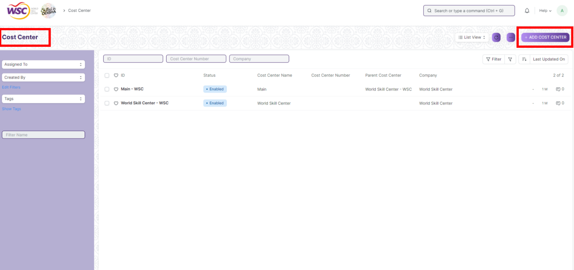

2. Enter ***Cost Center Name***, ***Parent Cost Center***, ***Company***

3. Check ***Is Group*** & ***Disabled*** check-boxes if required.

4. Click on ***Convert to Group*** button if it needs to be converted into a group.

5. ***Save***

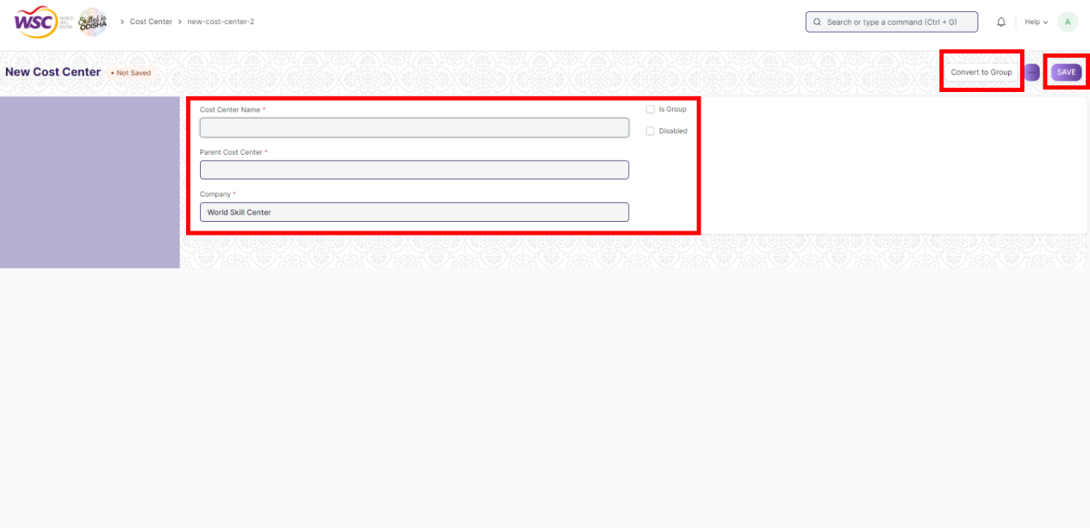

# Fixed Deposit :-

A fixed deposit (FD) is a [financial instrument](https://en.wikipedia.org/wiki/Financial_instrument" \o "Financial instrument) provided by banks or [non-bank financial institutions](https://en.wikipedia.org/wiki/Non-bank_financial_institution" \o "Non-bank financial institution) which provides investors a higher rate of [interest](https://en.wikipedia.org/wiki/Interest" \o "Interest) than a regular [savings account](https://en.wikipedia.org/wiki/Savings_account" \o "Savings account), until the given maturity date. It may or may not require the creation of a separate account. This screen will help in tracking Fixed Deposits.

**Screen**

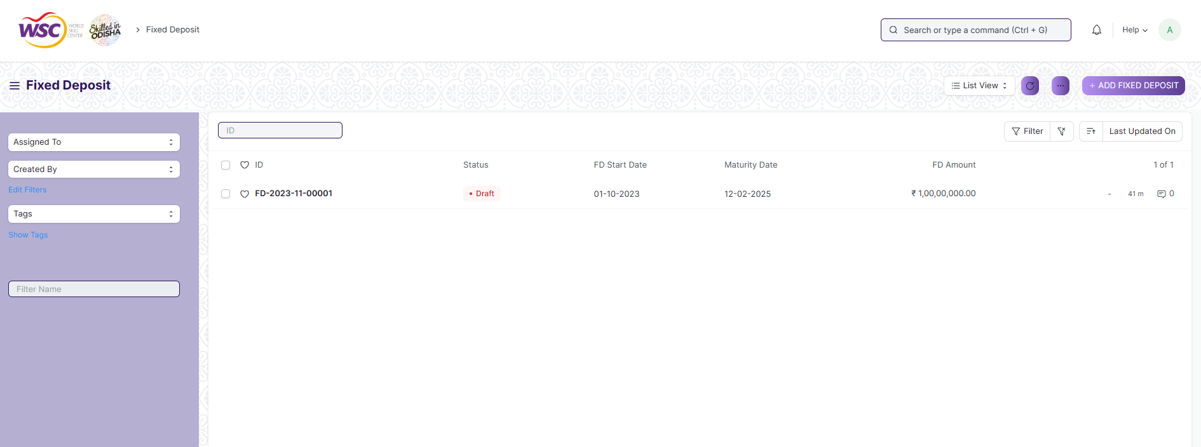

(List view of Fixed Deposit)

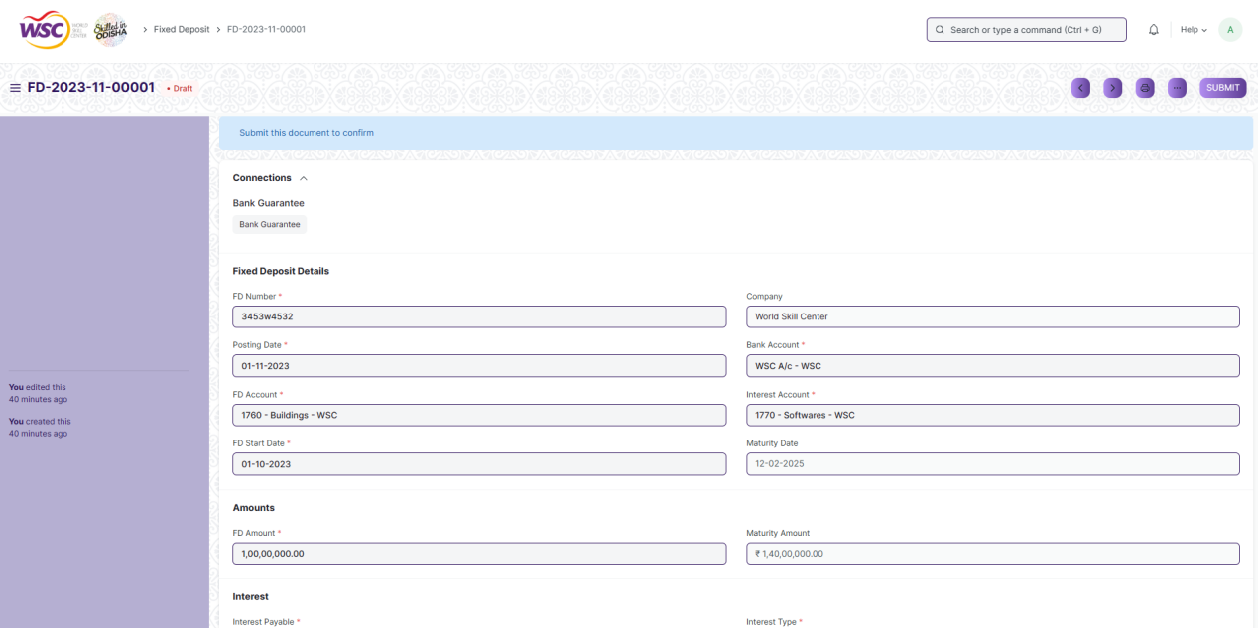

(View a saved record)

**Screen Type**

* Submittable

**Prerequisites**

* Account

**Adding a new record**

As it is a submittable screen, follow the general procedure to create a submittable document as mentioned above .

After creating a Fixed Deposit, the record will be visible in the List view of the screen.

**Deleting a record**

As it a submittable screen , follow the general procedure to delete a submittable document .

**Edit Record**

Follow the steps to view a saved Fixed Deposit.

Edit the field that you want to change.

If submitted, follow the general procedure to cancel and amend the document.

Click on Save.

**Print Record**

As it is a submittable screen , follow the general procedure to print a submittable document.

**View Record in different format**

As it is a submittable screen , follow the general procedure to view a submittable document in different format.

# Security: User access and authorization

The screens and the data in them is made secure by creating roles with different permissions and then assigning those roles the appropriate users. For this screen, following are the roles and their corresponding permissions:

**Company**

|  |  |  |  |  |  |  |  |  |
| --- | --- | --- | --- | --- | --- | --- | --- | --- |
| **ID** | **Role** | **Read** | **Write** | **Create** | **Delete** | **Submit** | **Cancel** | **Amend** |
| 1 | Account Manager | Yes | Yes | Yes | No | NA | NA | NA |
| 1 | Accountant Admin | Yes | Yes | Yes | No | NA | NA | NA |

**Account**

|  |  |  |  |  |  |  |  |  |
| --- | --- | --- | --- | --- | --- | --- | --- | --- |
| **ID** | **Role** | **Read** | **Write** | **Create** | **Delete** | **Submit** | **Cancel** | **Amend** |
| 1 | Account Manager | Yes | Yes | Yes | No | NA | NA | NA |
| 2 | Accountant Admin | Yes | Yes | Yes | No | NA | NA | NA |

**Fiscal Year**

|  |  |  |  |  |  |  |  |  |
| --- | --- | --- | --- | --- | --- | --- | --- | --- |
| **ID** | **Role** | **Read** | **Write** | **Create** | **Delete** | **Submit** | **Cancel** | **Amend** |
| 1 | Account Manager | Yes | Yes | Yes | No | NA | NA | NA |
| 2 | Accountant Admin | Yes | Yes | Yes | No | NA | NA | NA |

**Accounting Period**

|  |  |  |  |  |  |  |  |  |
| --- | --- | --- | --- | --- | --- | --- | --- | --- |
| **ID** | **Role** | **Read** | **Write** | **Create** | **Delete** | **Submit** | **Cancel** | **Amend** |
| 1 | Account Manager | Yes | Yes | Yes | No | NA | NA | NA |
| 2 | Accountant Admin | Yes | Yes | Yes | No | NA | NA | NA |

**Finance Book**

|  |  |  |  |  |  |  |  |  |
| --- | --- | --- | --- | --- | --- | --- | --- | --- |
| **ID** | **Role** | **Read** | **Write** | **Create** | **Delete** | **Submit** | **Cancel** | **Amend** |
| 1 | Account Manager | Yes | Yes | Yes | No | NA | NA | NA |
| 2 | Accountant Admin | Yes | Yes | Yes | No | NA | NA | NA |

**Bank**

|  |  |  |  |  |  |  |  |  |
| --- | --- | --- | --- | --- | --- | --- | --- | --- |
| **ID** | **Role** | **Read** | **Write** | **Create** | **Delete** | **Submit** | **Cancel** | **Amend** |
| 1 | Account Manager | Yes | Yes | Yes | No | NA | NA | NA |
| 2 | Accountant Admin | Yes | Yes | Yes | No | NA | NA | NA |

**Bank Account**

|  |  |  |  |  |  |  |  |  |
| --- | --- | --- | --- | --- | --- | --- | --- | --- |
| **ID** | **Role** | **Read** | **Write** | **Create** | **Delete** | **Submit** | **Cancel** | **Amend** |
| 1 | Account Manager | Yes | Yes | Yes | No | NA | NA | NA |
| 2 | Accountant Admin | Yes | Yes | Yes | No | NA | NA | NA |

**Mode of payment**

|  |  |  |  |  |  |  |  |  |
| --- | --- | --- | --- | --- | --- | --- | --- | --- |
| **ID** | **Role** | **Read** | **Write** | **Create** | **Delete** | **Submit** | **Cancel** | **Amend** |
| 1 | Account Manager | Yes | Yes | Yes | No | NA | NA | NA |
| 2 | Accountant Admin | Yes | Yes | Yes | No | NA | NA | NA |

**Currency**

|  |  |  |  |  |  |  |  |  |
| --- | --- | --- | --- | --- | --- | --- | --- | --- |
| **ID** | **Role** | **Read** | **Write** | **Create** | **Delete** | **Submit** | **Cancel** | **Amend** |
| 1 | Account Manager | No | No | No | No | NA | NA | NA |
| 2 | Accountant Admin | No | No | No | No | NA | NA | NA |

**Party Type**

|  |  |  |  |  |  |  |  |  |
| --- | --- | --- | --- | --- | --- | --- | --- | --- |
| **ID** | **Role** | **Read** | **Write** | **Create** | **Delete** | **Submit** | **Cancel** | **Amend** |
| 1 | Account Manager | No | No | No | No | NA | NA | NA |
| 2 | Accountant Admin | No | No | No | No | NA | NA | NA |

**Cost Center**

|  |  |  |  |  |  |  |  |  |
| --- | --- | --- | --- | --- | --- | --- | --- | --- |
| **ID** | **Role** | **Read** | **Write** | **Create** | **Delete** | **Submit** | **Cancel** | **Amend** |
| 1 | Account Manager | Yes | Yes | Yes | No | NA | NA | NA |
| 2 | Accountant Admin | Yes | Yes | Yes | No | NA | NA | NA |

**Accounting Dimension**

|  |  |  |  |  |  |  |  |  |
| --- | --- | --- | --- | --- | --- | --- | --- | --- |
| **ID** | **Role** | **Read** | **Write** | **Create** | **Delete** | **Submit** | **Cancel** | **Amend** |
| 1 | Account Manager | Yes | Yes | Yes | No | NA | NA | NA |
| 2 | Accountant Admin | Yes | Yes | Yes | No | NA | NA | NA |

**Journal Entry**

|  |  |  |  |  |  |  |  |  |
| --- | --- | --- | --- | --- | --- | --- | --- | --- |
| **ID** | **Role** | **Read** | **Write** | **Create** | **Delete** | **Submit** | **Cancel** | **Amend** |
| 1 | Accountant Admin | Yes | Yes | Yes | No | Yes | Yes | Yes |
| 2 | Account Manager | Yes | Yes | Yes | No | Yes | Yes | Yes |

**GL Entry**

|  |  |  |  |  |  |  |  |  |
| --- | --- | --- | --- | --- | --- | --- | --- | --- |
| **ID** | **Role** | **Read** | **Write** | **Create** | **Delete** | **Submit** | **Cancel** | **Amend** |
| 1 | Account User | No | No | No | No | NA | NA | NA |
| 2 | Account Manager | No | No | No | No | NA | NA | NA |
| 3 | Accountant Admin | No | No | No | No | NA | NA | NA |

**General Ledger**

|  |  |  |  |  |  |  |  |  |
| --- | --- | --- | --- | --- | --- | --- | --- | --- |
| **ID** | **Role** | **Read** | **Write** | **Create** | **Delete** | **Submit** | **Cancel** | **Amend** |
| 1 | Accountant Admin | Yes | Yes | NA | NA | NA | NA | NA |
| 2 | Account Manager | Yes | Yes | NA | NA | NA | NA | NA |

**Payment Entry**

|  |  |  |  |  |  |  |  |  |
| --- | --- | --- | --- | --- | --- | --- | --- | --- |
| **ID** | **Role** | **Read** | **Write** | **Create** | **Delete** | **Submit** | **Cancel** | **Amend** |
| 1 | Accountant Admin | Yes | Yes | Yes | No | Yes | Yes | Yes |
| 2 | Account Manager | Yes | Yes | Yes | No | Yes | No | Yes |

**Bank Reconciliation Tool**

|  |  |  |  |  |  |  |  |  |
| --- | --- | --- | --- | --- | --- | --- | --- | --- |
| **ID** | **Role** | **Read** | **Write** | **Create** | **Delete** | **Submit** | **Cancel** | **Amend** |
| 1 | Account Manager | Yes | Yes | Yes | No | NA | NA | NA |
| 2 | Accountant Admin | Yes | Yes | Yes | No | NA | NA | NA |

**Bank Clearance**

|  |  |  |  |  |  |  |  |  |
| --- | --- | --- | --- | --- | --- | --- | --- | --- |
| **ID** | **Role** | **Read** | **Write** | **Create** | **Delete** | **Submit** | **Cancel** | **Amend** |
| 1 | Account Manager | Yes | Yes | Yes | No | NA | NA | NA |
| 2 | Accountant Admin | Yes | Yes | Yes | No | NA | NA | NA |

**Bank Reconciliation Statement**

|  |  |  |  |  |  |  |  |  |
| --- | --- | --- | --- | --- | --- | --- | --- | --- |
| **ID** | **Role** | **Read** | **Write** | **Create** | **Delete** | **Submit** | **Cancel** | **Amend** |
| 1 | Accountant Admin | Yes | Yes | NA | NA | NA | NA | NA |
| 2 | Account Manager | Yes | Yes | NA | NA | NA | NA | NA |

**Accounts Receivable Report**

|  |  |  |  |  |  |  |  |  |
| --- | --- | --- | --- | --- | --- | --- | --- | --- |
| **ID** | **Role** | **Read** | **Write** | **Create** | **Delete** | **Submit** | **Cancel** | **Amend** |
| 1 | Accountant Admin | Yes | Yes | NA | NA | NA | NA | NA |
| 2 | Account Manager | Yes | Yes | NA | NA | NA | NA | NA |

**Accounts Receivable Summary Report**

|  |  |  |  |  |  |  |  |  |
| --- | --- | --- | --- | --- | --- | --- | --- | --- |
| **ID** | **Role** | **Read** | **Write** | **Create** | **Delete** | **Submit** | **Cancel** | **Amend** |
| 1 | Accountant Admin | Yes | Yes | NA | NA | NA | NA | NA |
| 2 | Account Manager | Yes | Yes | NA | NA | NA | NA | NA |

**Accounts Payable Report**

|  |  |  |  |  |  |  |  |  |
| --- | --- | --- | --- | --- | --- | --- | --- | --- |
| **ID** | **Role** | **Read** | **Write** | **Create** | **Delete** | **Submit** | **Cancel** | **Amend** |
| 1 | Accountant Admin | Yes | Yes | NA | NA | NA | NA | NA |
| 2 | Account Manager | Yes | Yes | NA | NA | NA | NA | NA |

**Accounts Payable Summary Report**

|  |  |  |  |  |  |  |  |  |
| --- | --- | --- | --- | --- | --- | --- | --- | --- |
| **ID** | **Role** | **Read** | **Write** | **Create** | **Delete** | **Submit** | **Cancel** | **Amend** |
| 1 | Accountant Admin | Yes | Yes | NA | NA | NA | NA | NA |
| 2 | Account Manager | Yes | Yes | NA | NA | NA | NA | NA |

**Purchase Register Report**

|  |  |  |  |  |  |  |  |  |
| --- | --- | --- | --- | --- | --- | --- | --- | --- |
| **ID** | **Role** | **Read** | **Write** | **Create** | **Delete** | **Submit** | **Cancel** | **Amend** |
| 1 | Accountant Admin | Yes | Yes | NA | NA | NA | NA | NA |
| 2 | Account Manager | Yes | Yes | NA | NA | NA | NA | NA |

**Item Wise Purchase Register Report**

|  |  |  |  |  |  |  |  |  |
| --- | --- | --- | --- | --- | --- | --- | --- | --- |
| **ID** | **Role** | **Read** | **Write** | **Create** | **Delete** | **Submit** | **Cancel** | **Amend** |
| 1 | Accountant Admin | Yes | Yes | NA | NA | NA | NA | NA |
| 2 | Account Manager | Yes | Yes | NA | NA | NA | NA | NA |

**Trial Balance for Party Report**

|  |  |  |  |  |  |  |  |  |
| --- | --- | --- | --- | --- | --- | --- | --- | --- |
| **ID** | **Role** | **Read** | **Write** | **Create** | **Delete** | **Submit** | **Cancel** | **Amend** |
|  | Account Admin | Yes | No | NA | NA | NA | NA | NA |
|  | Account Manager | Yes | No | NA | NA | NA | NA | NA |

**Tax Detail Report**

|  |  |  |  |  |  |  |  |  |
| --- | --- | --- | --- | --- | --- | --- | --- | --- |
| **ID** | **Role** | **Read** | **Write** | **Create** | **Delete** | **Submit** | **Cancel** | **Amend** |
|  | Account Manager | Yes | No | NA | NA | NA | NA | NA |
|  | Account Admin | Yes | Yes | NA | NA | NA | NA | NA |

**Supplier Ledger Summary Report**

|  |  |  |  |  |  |  |  |  |
| --- | --- | --- | --- | --- | --- | --- | --- | --- |
| **ID** | **Role** | **Read** | **Write** | **Create** | **Delete** | **Submit** | **Cancel** | **Amend** |
| 1 | Accountant Admin | Yes | Yes | NA | NA | NA | NA | NA |
| 2 | Account Manager | Yes | Yes | NA | NA | NA | NA | NA |

**Trial Balance**

|  |  |  |  |  |  |  |  |  |
| --- | --- | --- | --- | --- | --- | --- | --- | --- |
| **ID** | **Role** | **Read** | **Write** | **Create** | **Delete** | **Submit** | **Cancel** | **Amend** |
|  | Account Manager | Yes | No | NA | NA | NA | NA | NA |
|  | Account Admin | Yes | Yes | NA | NA | NA | NA | NA |

**Balance Sheet**

|  |  |  |  |  |  |  |  |  |
| --- | --- | --- | --- | --- | --- | --- | --- | --- |
| **ID** | **Role** | **Read** | **Write** | **Create** | **Delete** | **Submit** | **Cancel** | **Amend** |
|  | Account Manager | No | No | NA | NA | NA | NA | NA |
|  | Account Admin | Yes | Yes | NA | NA | NA | NA | NA |

**Profit and Loss Statement**

|  |  |  |  |  |  |  |  |  |
| --- | --- | --- | --- | --- | --- | --- | --- | --- |
| **ID** | **Role** | **Read** | **Write** | **Create** | **Delete** | **Submit** | **Cancel** | **Amend** |
|  | Account Manager | No | No | NA | NA | NA | NA | NA |
|  | Account Admin | Yes | Yes | NA | NA | NA | NA | NA |

**Cash Flow**

|  |  |  |  |  |  |  |  |  |
| --- | --- | --- | --- | --- | --- | --- | --- | --- |
| **ID** | **Role** | **Read** | **Write** | **Create** | **Delete** | **Submit** | **Cancel** | **Amend** |
|  | Account Manager | Yes | No | NA | NA | NA | NA | NA |
|  | Account Admin | Yes | Yes | NA | NA | NA | NA | NA |

**Consolidated Financial Statement**

|  |  |  |  |  |  |  |  |  |
| --- | --- | --- | --- | --- | --- | --- | --- | --- |
| **ID** | **Role** | **Read** | **Write** | **Create** | **Delete** | **Submit** | **Cancel** | **Amend** |
|  | Account Manager | No | No | NA | NA | NA | NA | NA |
|  | Account Admin | Yes | Yes | NA | NA | NA | NA | NA |

**Fixed Deposit**

|  |  |  |  |  |  |  |  |  |
| --- | --- | --- | --- | --- | --- | --- | --- | --- |
| **ID** | **Role** | **Read** | **Write** | **Create** | **Delete** | **Submit** | **Cancel** | **Amend** |
| 2 | Account Manager | Yes | Yes | Yes | No | NA | NA | NA |
| 3 | Accountant Admin | Yes | Yes | Yes | No | NA | NA | NA |